Institute of Management Studies
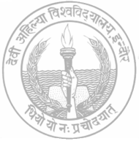
DEVI AHILYA VISHWAVIDYALAYA

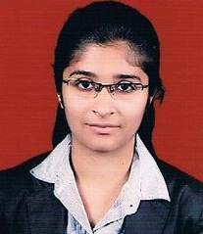
INDORE

Manmeet Kaur Hora

Address: B-402 Neha Appartrment , Near collectorate , Indore
Contact No.: +91-8982530254
E-mail Address: mahihora@gmail.com

OBJECTIVE

To secure a position in the organization that offers challenge and opportunity for my career development and at the same time serve the organization to the best of my capabilities.

EDUCATIONAL QUALIFICATION

- Post Graduation

QUALIFICATION | INSTITUTE | UNIVERSITY/BOARD | YEAR | CGPA
M.B.A (Hospital Administration)  II- Semester | Institute Of Management Studies , Indore | Devi Ahilya University | 2014 | 7.78
M.B.A (Hospital Administration)  I- Semester | Institute Of Management Studies , Indore | Devi Ahilya University | 2013 | 7.56

- Graduation

QUALIFICATION | INSTITUTE | UNIVERSITY/BOARD | YEAR | GGPA
B.B.A (Hospital Administration) | Institute Of Management Studies , Indore | Devi Ahilya University | 2010- 13 | 7.97

- Schooling
QUALIFICATION | INSTITUTE | UNIVERSITY/BOARD | YEAR | %AGE
Higher Secondary School | Malaw School,Indore | M.P Board | 2009-10 | 71.2 %

SUMMER TRAININGS AND PROJECTS

ORGANIZATION | DURATION | PROJECT TITLE / WORK DOMAIN
CARE HOSPITALS , Hyderabad | 4 weeks | “Awareness level of infection control among doctors”
Vishesh Hospital , Indore | 4 weeks | “FSN Analysis on Store”
Nidan Pathology , Indore | 3 months | “Cost & Benefit Analysis of Pathology”
Bombay Hospital, Indore | 4 weeks | “Practical training in Medical Records Management”
Gokuldas Hospital , Indore | 4 weeks | “Bio Medical Waste Management”
Choithram Hospital and Research Centre, Indore | 4 weeks | “Hospital General Administration”

PERSONAL PROFILE

    - Date of birth : 28/02/1992
    - Hobbies : Singing and Travelling
    - Strength : Optimistic , punctuality, flexible

SEMINAR/CONFERENCE

- III National Seminar on the “Management of Cancer Centers”
- Campaign program for the” Awareness lecture, exhibition and Diabetes detection camp”
- Participated in Seminar on “Standardization And Accreditation in Healthcare
- Participated in Seminar on “Indian Wisdom For Management Excellence & Self Management

DECLARATION

I hereby declare that all the above-mentioned information is true to the best of my knowledge and belief.

Date : 2/02/2015
Place: INDORE Manmeet Hora

