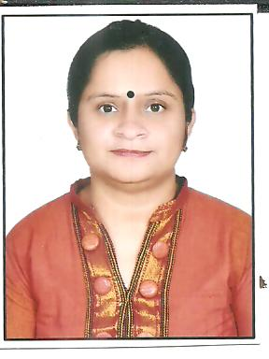

RACHNA SINGH

Sector- 5, Plot No-72, House No-203, Vaishali, Ghaziabad
Cell: 9213564908 Email:rachnasingh846@gmail.com

FACILITY MANAGER│HOUSEKEEPING MANAGER
Proven leader with 16 years’ success in managing a diverse range of housekeeping tasks. Well versed in maintaining high standards of excellence in the daily housekeeping operations. In depth know-how of leading housekeeping operations in accordance to hotel/hospital policies and procedures. Adept at monitoring and developing team member performance in terms of professional development and evaluations. Very effective in handling queries and complaints in a professional and resolution-oriented manner.
. RELEVANT CAPABILITIES
- Special talent for planning, organizing, scheduling, maintaining budgets
- Demonstrated ability to conduct inventories, and place purchase orders
- Extensive experience in recruiting and training of staff

PROFESSIONAL EXPERIENCE
Worked as:
- Corporate Manager Housekeeping with Cygnus Medicare from 2nd Jan 2015 till date.

- Manager Housekeeping with Panacea Newrise Hospital Gurgaon,
from May 15, 2013 – Dec 2013.

- Manager Housekeeping with Ministry of Health, India positioned at Dr.
RML Hospital, New Delhi from August, 2010 – August, 2012.

- Manager Housekeeping with Pushpanjali Crosslay Hospital,
Ghaziabad, from May, 2008 – July, 2010.

- Team Leader, Housekeeping Department with Max Super Specialty
Hospital, Saket, and New Delhi from July, 2006 – May, 2008

- Senior Supervisor, Housekeeping Department with Escorts Heart Institute
& Research Center, New Delhi from Jan, 2002 – Jun, 2006.

- House Keeping Supervisor at HOTEL INTERCONTINENTAL New Delhi
from May, 1998 – Jan, 2002.

Housekeeping Manager

- Direct performance of housekeeping staff
- Ensure maintenance and cleanliness of the hospital on a continuous basis
- Lead and direct housekeeping operations
- Ensure appropriate and safe use of chemicals and cleaning supplies
- Interview, hire and train housekeeping staff
- Prepare housekeeping budget
- Manage employee records
- Activate involvement in the NABH Assessment & maintain the records and standards as per NABH.
- Order housekeeping supplies and equipment
- Ensure maintenance of housekeeping equipment at all times
- Inspect guest rooms, lobbies and other guest areas to ensure cleanliness and tidiness.

Major Achievements:
- Reorganized the employee scheduling procedure by introducing a system that works
- Awarded Employee of the Year following exceptional cleaning and maintenance work practice.
- My greatest achievement helping mould my team in to the efficient and skilled professional machine that they are. As a result, the housekeeping team is more involved than ever before in a variety of internal activities.

Professional Qualification
“Bachelor in Hotel Management” from Indore Professional Studies Academy, Indore affiliated by “Devi Ahiliya Vishwa Vidyalya (DAVV), Indore”.

Skills:

- Working knowledge of rooms management systems.
- Excellent organizational skills.
- Strong ability to handle the staff and work pressure.
- Proficient in Microsoft Word, Excel, Access, Power Point, Internet.
- Proven comfort and experience to interact effectively with all levels of management, guests, associates, and clientele, both inside and outside of organization.
- Activator/self-motivated to accomplish goals, with a strong sense of responsibility.
- Capable of using independent judgment/solid decision making skills ability..

STRENGTHS
- Hardworking
- Self Motivated
- Enthusiasm in learning New Things
- Positive Thinking
- Punctual
- Discipline and flexible to work in any environment

BASIC INFO

Name : Mrs. Rachna Singh
Date of Birth : 19th Oct 1976
Nationality : Indian
Marital Status : Married
Language : Hindi, English

Date:
Place:
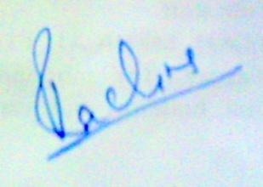
(Rachna Singh)

