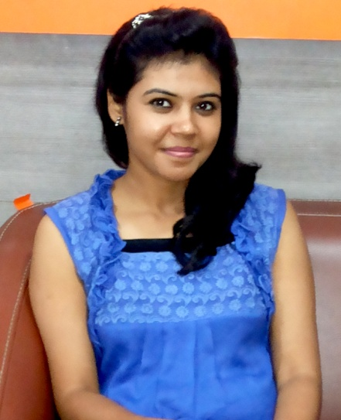  Permanent Address:  37 M.D ROAD, Dum Dum Cantoment, Kolkata-700028  Current Address:  C- 140, 3rd floor,  Avantika, Rohini-85  Mobile:  +91-9953544557  E-Mail:  bittuaruna@gmail.com  Personal Data:  Date of Birth : 22.03.1986  Gender : Female  Nationality : Indian  Marital Status : Married  Languages Known:  Hindi, English and Bengali  Interests :  Listening Music,  Reading (fictions and motivational) | ARUNA SINGH  Career Objective  .  To evolve as a learning individual and leverage it to create value for my organization.  tT  ACADEMIC QUALIFICATIONS  DEGREE BOARD/ UNIVERSITY YEAR PERCENTAGE  PERSUING MBA (Hospital Management) PGDHA-Hospital Administration APOLLO MEDVARSITY APOLLO MEDVARSITY 2015 2011-12 A Grade  B.Sc. (Bio Science ) CALCUTTA UNIVERSITY 2006-09 56  12th W.B Board 2006 55  10th W.B Board 2003 65  STRENGHTS  - Energetic, responsible and able to work hard as per requirement, good representative while working in a group. Good listener  SELF ASSESSMENT  - Nature – Persistent, Simple and Caring.  - Strengths – Capacity to focus on work, Goal oriented and Confident.  TECHNICAL QULIFICATIONS  - Diploma in information technology application from STATE YOUTH CENTER (W.B. Govt.) with grade ‘A’  EXPERIENCE  - Worked with Vasan Eye Care (India Largest Eye Care Network) 2 years as a Front Office Executive in Kohat Enclave Pitampura.  - Working with Centre for Sight (Asia’s Largest LASIK Network) Last 11 Month as a Sr. Billing Executive in Fortis Escorts Okhla.  I certify that information given above is true to the best of my knowledge.  (Aruna Singh)

