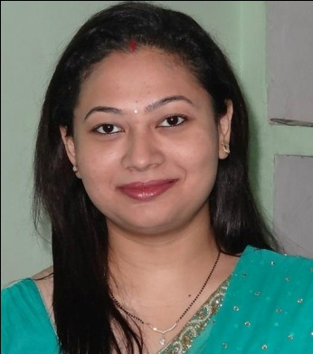  SHWETA AMARNEEL  Contact Information:  Present address  c/o Amrendra Kumar  4/8 Rajwest Township  Shivkar Road, Barmer  Rajasthan. 344001  Contact No:  +91-9687688484  +91-8000133991  +91-8447631240  +91-8094005350  Email: shwetadbga@gmail.com  Permanent Address  SURIMS Campus  Near Baijnath Cinema  Belan Bazar, Munger  Bihar ,India 811201  Personal Data:  DOB :19th Sep 1986  Sex : Female  Nationality : Indian.  . | CURRICULUM VITAE  Objective  To put to use the skills acquired during my studies in the service of mankind and simultaneously improving my skills by experience and further studies.  Professional Qualification  - MD (Pathology) Govt Medical College Bhavnagar, Gujrat.  - MBBS Patliputra Medical College Dhanbad, Jharkhand.  Paper publication and poster presentation  - Paper published on “ Pattern of anemia in elderly age ”  - Dessertation on “ Histopathological spectrum of prostatic lesion “  - Paper published on “Case report on sudden death in sickle cell anemia “  - Poster presentation on “ Case report on undifferentiated endometrial sarcoma”  - Paper published on “Hysterectomy: A Clinico-PathologicalCorrelation of 620 Cases”  - Paper published on “Study of Serum Prostate Specific Antigen Level in Prostate Biopsy Specimens”  Academic Record  +2:  - Central Board of Secondary Education.  - Done in Science Stream (Biology, Math’s, Physics & Chemistry).  - In the year 2003 with 80% marks.  10:  - Central Board of Secondary Education.  - Done in Science Stream  - In the Year 2001 with 82% marks  Competencies & Skills  - Hardworking.  - Studious  - Leadership.  - Optimistic.  - Self and Group Motivation.  - Sensitive to suffering of others.
Languages Known:  English  Hindi  Computer proficiency:  Microsoft Windows.  Microsoft office. |  | WORK EXPERIENCES  - One year internship at PMCH Dhanbad.  - Working as Sr Resident at Govt Medical College Bhavnagar, from June 2012 till date.  Special achievements  - Throughout excellent academic record.  - Got 1st position in MD Pathology.  Declaration  I confirm that the information provided by me is true to the best of my knowledge and belief.  Dr Shweta Amarneel  Place : Bhavnagar, Gujrat.  Date : 10/05/15

