Curriculum Vitae

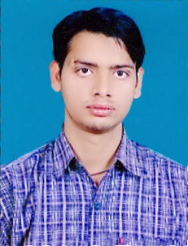

ABHILASH KUMAR

plot no-d-27

fourth lane vrindawan vihar

gaushala road ,balaganj

( behind eras hospital )

chowk

luclnow 226003

Contact No:-09161861037

Email Id:- Abhilash.761@Rediffmail.Com

Career Objective:-

To Be Part Of An Organization That Offers A Challenging, Stimulating, Learning Environment To

Work And Provides Scope For Individual Development And Offers Attractive Prospects For Long- Term Personal Development, Development And Career Growth.

Education Qualification:-

B.C.A- FROM ALAGAPPA UNIVERSITY KARAIKUDI TAMILNADU. In 2011

Intermediate:- From U.P In 2007. 1st Div.

High School:- From U.P Board In 2005. 1st Div.

Professional Qualification:-

Diploma In Computer Hardware & Networking

**Certificate in Office Automaion and Internet**

Extra Activity:-

Computer Operator,

And Data Operator

Internet, Ms-OFFICE ETC.

Type WRITER IN ENGLISH And Hindi.

Experience In Data Operator

And Speak English AND HINDI

**Experience:** 1- 4 Months **Work in (DCO) data collection officer at ezeead.**com

**2- 4 months experience in data entry operator in census 2011 ( government project tie up with karvy ltd.)**

Project:-

6 month HANDLING CCTNS PILOT Project In Wipro

Crime & Criminal Tracking Network & Systems (Cctns-2011)



Crime & Criminal Tracking

Network and Systems (CCTNS 2011)

E-Governance Mission Mode Project (MMP) of MHA GoI

Personal Detail:-

Father’s Name Hans raj Seth

Date Of Birth 22/12/1989

Gender Male

Hobbies Reading Magazine, News Paper& Listening Music

Nationality Indian

Language Known Hindi & English

Permanent Address d-27 fourth lane vrindawan vihar colony

gausala road balaganj

behind eras hospital

chowk lucknow

Dist:- lucknow . Uttar Pradesh

mo- 9161861037

Declaration:-

I Hereby Declare That Above Mentioned Information Details Are True

To Best Of My Knowledge. If Given A Chance I Will Prove My Worth To The Organization.

date :-

Place…………lucknow…….. Abhilash Kumar