RAM KISHORE  E-mail: ramkishorurad23@gmail.com  Mobile: 09649418896  Address for communication:  Village Rawliyawas Post Kitalsar  The. Degana Dist. Nagaur (Raj) PIN.341503  Personal Information  Father's Name :Mr. Ghasi ram  Date of Birth : June, 01, 1991  Sex : Male  Nationality : Indian  Marital Status : Single  Languages : English , Hindi | Career Objective  To build my carrier with an organization which can utilize my ability resulting in the growth 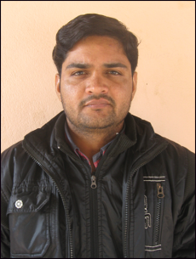of the organization. Seeking a entry level position in the pharmaceutical sector to use and develop my knowledge and skills with the profit of the organization  Education  B.scMLT Medical Lab Technician  PTU JHALANDAR  B.scMLT - 75.33%  Higher Secondary (Class XII)  RBSE  Percentage – 62.00%  Secondary (Class X)  RBSE  Percentage –68.30%  BASIC ( Computer Course)
Hobbies | - Reading Books,Debate,Swimming
Achievements | - Win 1st Position Cricket At State Level Sports.Bundi
Work Experience | - Two Year Work Experience In Reliable DIAGNOSTICS Center Jaipur(NABL) as Lab Technician  - One Year Work Experience In SHATI HOSPITAL Gurgaon as Lab Technician  - Six month work experience in AVNEESH HOSPITAL as Lab Technician
EQUIPNENT HANDLING : | - Advia Centaur immunoassay System Sicmens  - Dia Sorin Liaison  - @Architech I 1000SR  - Cobas e411 Roche  - Elisa Reader Strip Elisa Analyser instrument  - Erba manchcim EM-360 Biochemistry  - Erba manchcim EM-200 Biochemistry  - Erba manchicim Chem-5 Plus V2
STRENGTHS | - Intelligence & common sense  - Hard work & commitment  - A very positive & influential attitude  - Honesty & Integrity of character
SELF PROFILE | - A dedicated, self motivated individual with a great sense of responsibility. Honesty, hard work and tactfulness form the core of my personality. I believe that persistence can make most things possible if not all. Believe in teamwork and have experienced that trust; competence and commitment build stronger teams.

RAM KISHORE

