Mr. Ananda kumar.L
B.sc Nursing (RGUHS), M.H.A.(Manipal Uiversity).
PGDMLE ( National Law school of India university, Bengaluru)

Contact details:

Email : ananda.naik206@gmail.com
Mobile : 09886288500
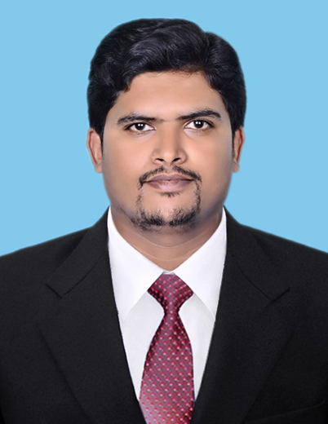
Executive summary : Healthcare professional with a Bachelor’s degree in Nursing( B.Sc.) from Rajiv Gandhi university of health science, Karnataka. Pursuing Master’s degree in Hospital administration (M.H.A.) from manipal university (manipal).
Currently pursuing post-graduate Diploma in Medical law and Ethics (PGDMLE) from National Law School of India university(2014 batch), Bengaluru.

Training: I have undergone internal counselor programme on NABH / SHCO standards conducted by Quality Council of India.

Assisted in internal auditing at Kasturba Hospital for NABH accreditation as an Operation trainee for one Month.

I have conducted study on Patient Identification Band for NABH accreditation Process at Kasturba Hospital (Manipal).

Last profile : I have worked as Nursing Tutor in Miranda college of Nursing, Bengaluru. from march 2010 to August 2013 (3 years, 6 month).

Subject taught:
a) Psychiatric Nursing
b) Medical Surgical Nursing
c) Community Health Nursing
d) Nursing Administration and Management

Computer skills:

Good in MS word, PowerPoint and good knowledge in handling the computer.

DATE OF BIRTH: 20-06-1985

EDUCATION : Pursuing Master’s in Hospital Administration from Manipal university, Manipal.

Expected date of completion July 2015.

Pursuing Post-graduate diploma in medical Law and Ethics (PGDMLE) from National Law School of India University, Bengaluru.

Expected date of Completion August 2015.

Rajiv Gandhi University of health sciences, Karnataka.
B.sc (Nursing).

Degree received: March 2010.

Work experience: worked as Nursing Tutor in Miranda college of Nursing, Bengaluru.( 3Year 6 Month).

M.H.A. Project Title: compliance of WHO Surgical safety Checklist and Surgical outcome in tertiary Care Hospital.

Guide: Dr. Arun.M.S( M.B.B.S, MD) Hospital Administration

Manager on Duty: Worked as Manager on Duty in Kasturba Hospital as part of Course Curriculum

Area of Exposure during Course Period at Kasturba Hospital(Manipal) :

I have studied, the structure, organogram, staffing pattern, location, workflow of each department and suggested sensible recommendations and tried to analyze the work related problems and suggested certain solutions.
Had regular postings in these following areas for 15 days each

- Medical record Department.
- Enquiry &Registration.
- Information Technology.
- Admission &IP Billing.
- Transportation and Ambulance Service.
- Marketing Department.
- Purchase and Finance Department.
- Dietary Department
- Biomedical Department.
- Housekeeping departments.
- CSSD
- Physiotherapy Department & Artificial Limb center
- ICU & Trauma
- Operation Theater
- Pharmacy.
- Human resource Department.
- Quality department.
- Linen and Laundry Department.
- Medical laboratory
- Blood bank
- Radiology department

Languages Proficiency :

Languages | Known to Speak | Known to Write
Kannada
English
Hindi

Hobbies : Reading Books, playing games, Music,travelling

Conferences, Workshops attended :

• Presented Research paper as Co Author in National Conference on “Evaluation of Hospital Infection Control practices in a Tertiary Care Hospital” organized by Department of Hospital Administration, SGPGIMS, Lucknow.

• Presented research paper as Author in National conference SASH on “Compliance of WHO Surgical safety checklist and surgical outcomes in a selected specialty in a tertiary care hospital” Organized by AHA Chapter, Bangalore

• CME on Emerging Trends in Hospital Management organized by A.J. Institute of Hospital Management, Mangalore.

• National Seminar on Healthcare Management (NASHCAM-2013) at Kasturba Medical College, MANIPAL.

• CME Hospital planning and Safety in Hospitals (2014) organized by Yenepoya Medical College, Mangalore.

• CME on Medical Practice and Legal Issues (MePLe-2015) organized by Department of Hospital Administration, KMC.

• CME on Disaster Management in Hospital organized by A.J. Institute of Hospital Management, Mangalore.

REFERENCES :
1. Dr.Somu.G, M.B.B.S, MD.(Hospital Administration) (Manipal)
Head of Department (H.O.D.),
Department of Hospital Administration,
Manipal University,
Manipal.
Email: gsomu2007@gmail.com
Mobile: 09448463186
2. Mr. Sudhakar Prabhu
DGM Finance Department
Kasturba Hospital
Manipal- 576104.
Email: spmpl2004@gmial.com
Phone: + 91 -9945699220

