DEVENDRA LAKHOTIA (CURRICULUM VITAE)
MS (ORTHO), DNB (ORTHO), MNAMS (ORTHO)
ATLS (JPNATC, AIIMS, NEW DELHI)
EX SENIOR RESIDENT (AIIMS, NEW DELHI)
ARTHROPLASTY FELLOW (KOREA UNIVERSIT MEDICAL CENTER, SEOUL)

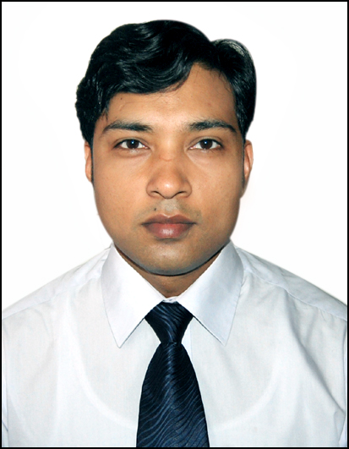

Personal Details
DOB/ Age : 22ND APRIL 1982/ 33 years

Nationality : Indian

Home Address : 104 a, pocket a, DDA flats, Sukhdev Vihar, New Delhi, India -110025

Present : Fortis hospital, noida (Clinical associate)
Workplace
Previous
Workplace : Clinical and research Fellow in hip and knee arthroplasty, Guro hospital,KUMC(Korean university medical centre),Seoul,South Korea

Mobile : 09958560438, 08595134761

E-mail Address : drdevendra.ortho@gmail.com

Educational Qualifications

S.No | Degree | University/Board | College/School | Year
1 | Master of Surgery (Orthopaedics) | Rajasthan University of Health sciences | SardarPatel Medical College,Bikaner | 2011
2  3 | Bachelor of Medicine & Bachelor of Surgery (MBBS)  Diplomate of National Board (DNB)(Orthopaedics) | Rajasthan university  National Board of Examinations (NBE) | SawaiMansingh Medical College,Jaipur | 2006  2012
 | Work Experience
Total work experience after post graduation: 4 years

- From April 2015 till present as clinical associate in Fortis Hospital, Noida.
- From 25 august 2014 to 14 march-2015, Clinical and Research Fellow in Hip and Knee arthroplasty, Guro hospital, KUMC, Seoul, South Korea
- From 16th August 2011 to 15 August 2014, worked as Senior registrar in Department of Orthopedics, All India Institute of Medical Sciences(AIIMS), Ansari Nagar, Delhi – 110029
- From 21st June 2011 to 5th august 2011 ,working as Senior registrar in Department of Orthopedics, Sardar Patel Medical College, Bikaner
- From 10thjune 2008 to 9thjune 2011 (3 years), worked as Junior resident (Postgraduate) in the Department of Orthopedics at Sardar Patel Medical College, Bikaner

Thesis

Thesis titled “A Clinical study to evaluate Benefits, risks involved and ‘personal and socioeconomic consequences’ after Total hip replacement in low socioeconomic group using modified Harris hip Score.” submitted to Rajasthan University of Health sciences

Publications
1. Pertrochanteric fractures (AO/OTA 31-A1 and A2) not amenable to closed reduction: Causes of irreducibility.Sharma G, Gn KK, Yadav S, Lakhotia D, Singh R, Gamanagatti S, Sharma V.
Injury. 2014 Oct 27;45(12):1950-1957. doi: 10.1016/j.injury.2014.10.007.

2. Locking compression plate in distal femoral intra articular fractures –our experience. G. N. Kiran Kumar, Gaurav Sharma, Kamran Farooque, Vijay Sharma, RatnavRatan, Sanjay Yadav, and DevendraLakhotia.International Scholarly Research Notices.Volume2014, Article ID 372916
http://dx.doi.org/10.1155/2014/372916
3. Rare presentation of breakage of tip of unreamed intramedullary nail and bypassing of rest of nail by its side during insertion -journal of delhi orthopedic association. 2010 Issue: Vol 1 | No. 2 | December 2010 | Pages 57-120

4.Functional Evaluation in High Energy (Schatzker Type V and Type VI) Tibial Plateau Fractures Treated by Open Reduction and Internal Fixation, KavinKhatri, DevendraLakhotia, Vijay Sharma, G. N. Kiran Kumar, Gaurav Sharma, and Kamran Farooque .International scholar reaserch notices-ISRN,Volume 2014 (2014), Article ID 589538
http://dx.doi.org/10.1155/2014/589538

5. Efficacy of Debridement for Early PeriprostheticJoint Infection after Hip Arthroplasty. Jong HoonKim, Sung Kwang Chun, Yong Cheol Yoon, DevendraLakhotia, Won Yong Shon. Hip Pelvis 26(4): 000-000, 2014. http://dx.doi.org/10.5371/hp.2014.26.4.000

Lectures

LECTURE: “TOTAL ARTHROPLASTY OF HIP AND KNEE AND RECENT CONCEPT” IN CME ON 9TH JULY 2011 FROM BIKANER ORTHOPEDIC ASSOCIATION

Other
ATLS-Advanced Trauma Life Support (ATLS) Course: JULY 2014

