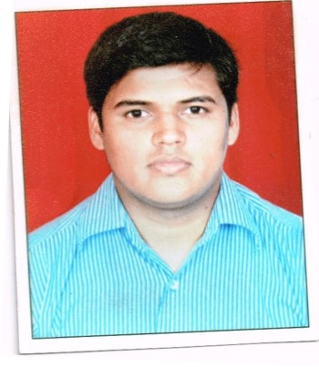
Resume
H/NO. K/8/945, Kalinga Nagar, BBSR
E-mail: hospadm13@gmail.com
Mob: 08895295278,9498304454

Professional Objective

To serve people by curing their ailment as well as full utilization of my capabilities & Skills to improve the Organizational Quality as well as give appropriate commitment & service to the Organization.

Educational Qualification

Degree | Year |  | Institution/University | Total Percentage
 | Enrolled | Passed
MASTER OF HOSPITAL ADMINISTRATION | 2013 | 2015 | INSTITUTE OF BUSINESS SCIENCE AND COMPUTER STUDIES,BBSR | CGPA- 8.98
BACHELOR IN COMPUTER SCIENCE | 2010 | 2013 | SAM HIGGINBOTTOM INSTITUTE OF AGRICULTURE AND SCIENCE ,ALLAHABAD | 70
INTERMEDIATE | 2005 | 2007 | MILLER INTER HIGH SCHOOL | 60
MATRICULATION | 2003 | 2004 | MILLER HIGH SCHOOL,PATNA | 72.5

Work Experience
.
- Currently working as a Junior Hospital Administrator in Quality Department at IMS & Sum Hospital, Bhubaneswar.
- Worked as a Asst. Medical Record Manager at IMS & Sum Hospital, Bhubaneswar at the time of UG and PG MCI Visit from 01 Dec 14 to 31 March 15.
- Worked as a Computer Assistant at IMS & Sum Hospital, Bhubaneswar from Nov 2007 to Dec 2009.

Areas of Interest

- Human Resource Management in Hospitals.
- Hospital Management Information System in Hospitals.
- Principles of Management.
- Public Relation In Healthcare.

Projects and Conferences

- 3 months project on “ A study on Human Resource Audit” at IMS and Sum Hospital, BBSR for the partial fulfillment of MHA.
- 3 Months project on Utilization of Hospital Information System at AMRI, BBSR.
- Attended National Conference on Recent Trends in Hospital Administration in Mar 2014.

IT Skills

- SPSS, M.S Office, Good Savvy of internet.
- Working experience on Different Hospital Management Software.

Strengths

- Believe in Honesty & Punctuality.
- Laborious and Optimistic.
- Willing to shoulder responsibilities.
- Flexible and willing to learn New Tools and Techniques.

Personal Details

Date of Birth : 10TH Jan 1990
Nationality : Indian
Language Known : Hindi, English
Pan Card : Available
Hobbies : Dancing, Cartoon painting, Travel and Tourism.
Permanent Address : House No. D/3, New A.G.Colony, Danapur Patna

Date:- (Mohit Kumar)
Place: - BBSR

