CURRICULUM VITAE 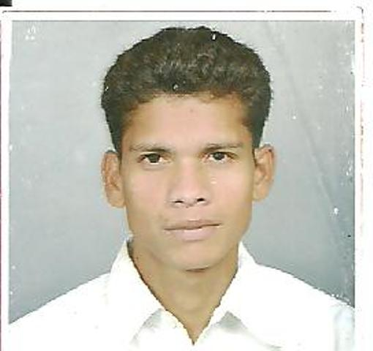

Suresh dhurve  Email:  Suresh45dhurve@gmail.com  Mobile no. :  +919907595603  +918874992205  Permanent Address  Suresh dhurve  4/6 anand laoundri usha  ganj chawani indore(m.p)  452001  Personal Data  Name : Suresh dhurve  Father name : Jugri dhurve  Date of Birth : 10 may 1986  Marital Status: Unmarried  Hobbies :Music,Reading,cricket Nationality : Indian  Language : Hindi, English | Objective:  MY idea of a career is one which offers me challenging roles and  Responsibilities Leading to the continues growth of the self and the organization  Technical Qualification:  - Complete B.E biomedical engineering with 62.31% from S.G.S.I.T.S, Indore (M.P.) affiliated to Rajiv Gandhi ProudyogikiVishwavidhyalaya, Bhopal, (M.P.).in 2012  - Complete diploma in Bio-Medical Equipment Maintenance and technology with 72.92 from C-DAC. Mohali (Punjab) Chandigarh in 2014. Under center government of India  Working experience/ training  - Working at present Head of biomedical engineer service and maintenance in Rama Hospital Kanpur (u.p) in biomedical engineering department since one year 5 month from august 2015 to present til date in February 2017  - worked as a biomedical engineer service and maintenance in suyash hospital Raipur (Chhattisgarh) in biomedical engineering department since one year from august 2014 to august 2015  - Worked as a biomedical equipments service engineer in “Universal medico healthcare pvt.ltdbhilai, Raipur (c.g&orisa regon) in "for three month from June 2014 to august 2014.  - Worked as a biomedical engineer trainee at “max hospital mohali (Punjab) Chandigarh in service and maintenance of biomedical engineering department for two months from April 2014 to June 2014.  - Training of installation and testing of cardiac, therapeutic, and, imaging, equipments at 6th months in “C-DAC mohali (Punjab) Chandigarh from January 2014 to June 2014.  - One month training in biomedical equipments functioning and understand all types of equipments at “CHL APOLLO HOSPITAL INDORE (m.p). from April 2011 to may 2011.

Education:

Examination | Discipline/  Specialization | School/College | Board/  University | Year of  Passing | %
Bachelor of engineering | Bio-Medical | ShriGovindramSeksaria Institute Of Technology And Science Indore | Rajiv Gandhi ProudyogikiVishwavidyalaya  Bhopal (M.P.) | 2012 | 62.31%
diploma | Biomedical equipment maintains & technology | C-DAC mohali (Punjab) Chandigarh | Center government of India | 2014 | 72.92%
High Secondary school certificate | 12th | NBHS koti bazaar betul | M.P. Board Bhopal | 2004 | 70.02%
High school certificate | 10th | Nasirabaad | M.P. Board Bhopal | 2002 | 59.08%

Projects Done:

Minor Project

Name of project | Electronic power supply
Environment | Printed circuit board Fabrication& Circuit designing, Fiber tube
Role | Team leader
Project Description | Electronic power supply

Major Project

Name of project | The method of EOG signal processing to detect the direction of eye movement
Environment | Printed circuit board Fabrication &Advanced circuit designing embedded system.
Role | Team leader
Project Description | The method of EOG signal processing to detect the direction of eye movement

Computer /software skill

- Diploma of computer application(DCA)
- Basic knowledge of operating system
- Application packages: MS office

STRENGTHS:

- Interested in taking up the responsibility and fulfilling it.
- Can work in a team and achieve excellent results.
- Ability to work under pressure and willingness to relocate.
- Ease of motivation.

KEY SKILLS IN BIOMEDICAL ENGINEERING DEPARTMENT

TECHNICAL KNOWLEDGE:

- Basic knowledge of maintaining biomedical equipment’s in hospital department “ICU, CCU, CATHLAB, NICU, SICU, MICU, GICU, OT, EMERGENCY, IPD,CSSD and radiology department
- Knowledge about in repair and maintenance of biomedical equipment’s.
- All Radiology Equipment’s ( MRI ,CT Scan, X-Ray, C-Arm, Mammography, OPG, Ultrasound machine)
- All Cardiology Equipment’s (CATH lab, ICU Ventilator, Cardiac Monitor, Defibrillator )
- All Pathology Analyzers
- All Blood banks Equipment ( Blood bank fridge, Deep freezer, Ultra low freezer, Tube sealer, Laminar air flow
- Other equipment’s like Dental chair, dental equipment
- CSSD Equipment (Autoclave, Drying Cabinet, Instrument Washer, Ultrasonic Cleaner)
- All Dialysis Equipment (Dialysis Machine, RO Plant) Fetal Monitor, Fetal Doppler)
- All NICU, PICU equipment (Infant Warmer, Photo Therapy, Ventilator,
- All OT equipment ( Anesthesia Machine , OT Light, Surgical Diathermy, OT Table, Endoscopic Equipment)

DOCCUMENTATION:

- Inventory management and codification of All biomedical Equipment’s
- PM schedule for all medical equipment’s
- History card for all Medical equipment’s
- AMC/CMC for all Medical equipment’s
- All Medical record
- To make Technical Specifications Comparatives before purchasing
- Pre Purchase requirement with all documentation( Indent, Purchase Order, Capital Performa Purchase)
- Condemnation report for all medical equipment.
- Basic knowledge about in critical area routine checks up in personal detail and attends breakdown call of equipment’s.

JOB R ESPONSIBILITIES:

- Installation of all medical Equipment.
- Verification of medical equipments at the time of delivery.
- Coordination with vendor for Purchasing/Installation/AMC/CMC/PMS/Service.
- To ensure successful installation & demonstration for all medical equipments with user satisfactory report.
- To reduce down time of all medical equipments
- Preventive maintenance of all medical equipments.
- To make debit note for delay in service or manufacturer defects in equipments.
- To provide telephonic support for team to resolve the complaint/problem
- At the time of emergency break down ready to attend the duty round the clock.
To ensure condemnation of all medical equipments.

PERSONAL DETAIL:

Name : Suresh dhurve
Father name : Jugri dhurve
Date of Birth : 10 may 1986
Marital Status : Unmarried
Hobbies : Music, Reading, cricket
Nationality : Indian
Language knowledge : Hindi, English

Declaration :

I hereby declare that all the details furnished above are true to the best of my knowledge.

Date 03./02/2017
Place: Indore (Suresh dhurve)

