Resume

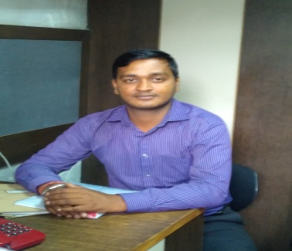Manish Upadhyay
S/O Rakesh Upadhyay

E-Mail: mupadhyay70@gmail.com Mobile: +91 9582426022 ,
mupadhyay661@yahoo.com +91 8800695013

Job Objective
To serve the organization in the capacity which will exploit my abilities of persistence, commitment and team effort to usher me to a key strategic decision making position in congruence with the growth of the organization.
Executive Summary
- I had worked Blue Angel & Security System Pvt. Ltd. as service engineer for One Year .
- I had Worked Jolly technocrats as sales and sen. Service engineer for two and half year.
- I am working Rohanika Electronics and Medical System from last three year as Sen. Customer support Engineer.
EDUCATIONAL QUALIFICATION
- 10th from CBSE board Delhi.
- 12th from CBSE Board from with science stream Delhi .
- Diploma (Medical Electronics) Completed from Board of Technical Education Delhi.
- B A Programme Passed from Delhi University.
- Perusing B-Tech Electronics and Telecommunication from I E T E Lodhi Road Delhi.
- Knowledge of handling clients, familiar with internet , MS Office & MS Excel .
KEY FUNCTIONAL AREA
Worked in Rohanika Electronics and Medical Systems Pvt. Ltd . working in Technical Operations -Customer Support & also handling admin work, paper work etc ,
1 Handling Technical support , Customer support and Product Demonstration for product sales support .
2 Technical Knowledge of medical equipment as OT Light , OT Table, Cryo instrument , Photo therapy Unit , Diathermy unit, microdarmavision, Puva Unit , Puva chamber, Crash card trolley, Portable suction unit, Laser unit, Laser Therapy unit, Ventilators, Monitors, Defibilator, syringe pump , IV Pole, Blood Infusion warmer , Warmer therapy unit ,vasacular doppler .

3. Customer support and technical support field product demonstration.
4. To maintain office Administration and paper work.
5 . Repairing instrument and customer satisfaction with good technical client
6. Preparing Performance report.
Strength
- Strong analytical and organizational skills.
- Excellent interpersonal skills.

Personal Detail :-
Address : E – 2/130 5th Pusta Sonia Vihar
Shri Ram Marg New Delhi-110094.

Date of Birth : 22 Aug 1987.
Languages Known : English and Hindi
Location Preference : Delhi/NCR
Marital Status : married

DATE :- …………………….............
PLACE :- ………………………………….

( Manish Upadhyay )

