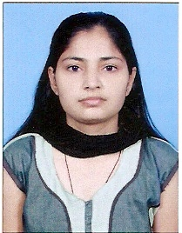 RESUME
Present Address
1141, 3rd floor
Mukherjee Nagar, Delhi-110009
Mobile: 8447510949,9999327527
Email:- ruksanadelhi@gmail.com

RUKSANA

Objective

To serve an esteemed organization and enhance my skills by applying my academic knowledge to prove my worth in practical as well as in professional field.
--------------------------------------------------------------------------

Total training: Training (GNM) three & half year with internship training period spent in modern State of the art Hospitals in Noida and Greater Noida, India.

Training & Work Experience

- Medical Intensive Care Unit (MICU)
- Emergency/Casualty
- High Density unit (HDU)

a) Patient preparation.
B) Complete Patient Care Pre & Post Operative.
c) Proper monitoring of all the parameters of the patient.

Experience:

# Staff Nurse at St. Stephen’s Hospital, New Delhi in Male Surgical Post-operative Ward & Maternity Post-operative Ward from 15th Dec 2012 to till date.

Educational Qualification

- Diploma in General Nursing & Midwifery (GNM)
- 12th Passed from U. P. Board (2008)
- 10th Passed from U. P. Board (2005)

Personal Details
- Permanent Address
Kashiram Nagar Bhogpur Mithoni
Block-E, H. No.-142, Moradabad, U.P.

- Father’s Name - Mr. Babu Shah
- Date of birth - 10th July 1989
- Languages Known - Hindi & English
- Marital Status - Unmarried
- Religion - Muslim
- Gender - Female
--------------------------------------------------------

Place: - New Delhi
(Ruksana)
Date:

