CURRICULAM VITAE - 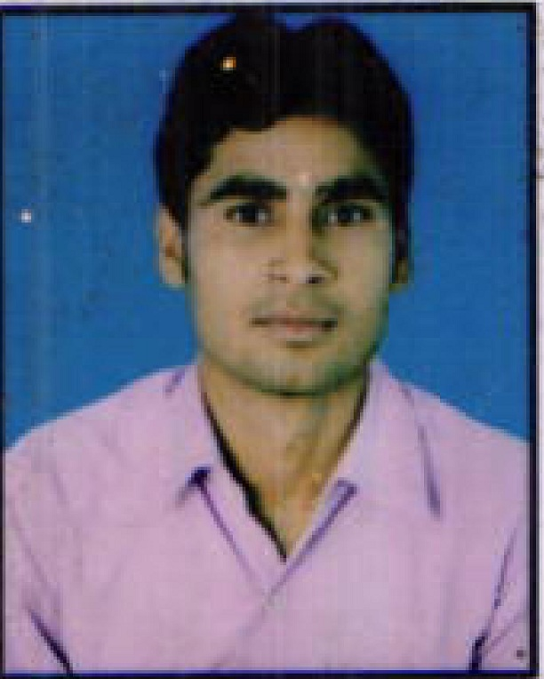

Neelesh Kumar shrivastava
ADD- paschim vihar New delhi-110056
Dust.- New Delhi.
Mob. No.-+919069283042, 8802818077
E-mail:- neelesh.cicst92@gmail.com

Career Objective:-

To secure job which gives me chance to utilize my skills & talents to the best which helps me in the obtaining a challenging position where opportunity development is ample by keeping for organization goal in mind.

EDUCATIONAL QUALIFICATIONS

Examination | Discipline/Specialization | School/College |  | Board/University | Year of passing | Percentage
Graduation | (B.C.A)Bachelor of computer application | CICST college Karwi |  | M..P. board  BHOPAL | 2014 | 70.33%
Intermediate | ART | ATARRA |  | U.P. board Allahabad | 2011 | 66.66%
High School | All Subject |  | ATARRA | U.P .Board Allahabad | 2009 | 51.16%

Computer knowledge_ computer(hardware& software)

Computer typing(English & Hindi)

Work Experience -(Four Year)-
- Park hospital gurgaon sec-47 in,(ECHS,CGHS,ESIC)(Billing & Processing Executive Department From 25/03/ 2012 TO 10/12/2014.

2. Alchemist hospital gurgaon in Sec-53 ECHS,CGHS, Claim Processing Executive

(Team Leader) Department From 15/01/2015 To 21/09/2016

3. Presently working with (DCDC Health services pvt. Ltd. Delhi ) Billing executive Department From 22/09/2016 To Till date.

Technical skill:-

Tools :- Microsoft Power Point, Ms, Excel, Microsoft Word

Major Project - major project on "SARTHAK EDUCATION"

Team size 3 members

Position- Team leader

Personal Details:-

Father’s Name Mr. Ramlakhan
Mother’s Name Mrs. Sarita Devi
Nationality Indian
Language English, Hindi
Date of Birth 18-05-1992
Marital Status Single

.

Strong Point:-

- Keen observer
- Focused to determined
- Grasping power & positive attitude
- Adoptive nature

Declaration:-

I hereby declare that above-mentioned information is correct up to my knowledge & I bear responsibility for correctness of the above-mentioned particulars.

Date:

Place: (Neelesh Kumar shrivastava)

