Name : Malika Arora
NRIC No. / FIN : G1531015X
Date of Birth : 20 December 1993
Nationality : Indian
Permanent
Address : P-6 Naveen Shadhara, New Delhi - 110032
Temporary
Address : #09-04, 90 St. Francis court, Singapore 328071
Mobile No. : +91-9811911941
Email Address : malika.arora93@yahoo.com

Personal Particulars
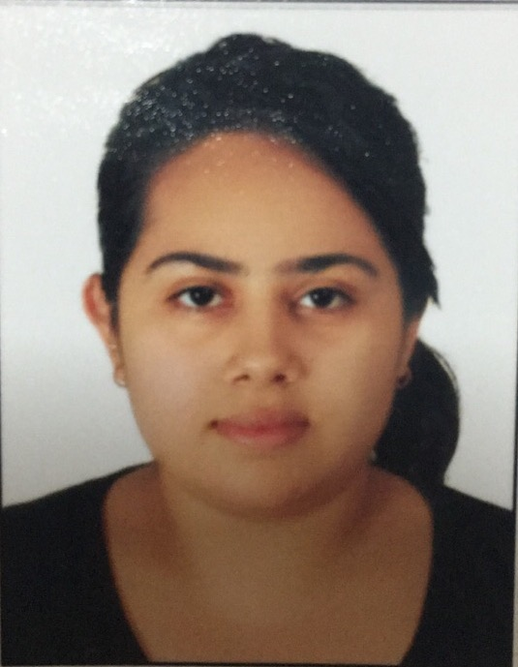
Education

Certification level : Master of Business administration
- Awarded by Anglia Ruskin University, UK
Name of School : Amity Global Business School,
100 Victoria Street, National Library Building, Singapore-188064
Duration : September 2015 to September 2016

Certification level : Bachelor of Science
- Awarded by University of Delhi
Name of School : Institute of Home Economics,
F-4 hauz khas, New Delhi
Duration : June 2012 to June 2015

Work Experience

Company : Talent Valley
Location : New Delhi
Position : Recruiter
Duration : February 2015 to August 2015

My role as per HR Recruiter was Sourcing of candidates from different portals and data reports then the Screening and Short listing according of the candidates according to the companies or clients requirements and demands. Briefing short listed candidates for the interview; about the company, about the process or area they are about to work in and various questions that need to be answered in the interview. Last role was Coordination; coordinating with different clients and candidates during the time of interview maintaining records for the same and follow ups with them.

Extra-Curricular Activities

- Travelling
- Swimming
- Listening music

Awards and Participation

Institute of Home Economics short term courses
AutoCAD and Interior Design 2013-2014
- Making plans on AutoCAD
- Designing
- Color schemes
- Elevations
IHE Student Council
- Member
- 2013 to 2014
IHE FERIA’13
- Volunteer

Jaipuria Institute of Management
- One day MBA experiential workshop, 24 October,2013

International English Language Testing system (IELTS)
- Professional certificate of English , 2015

Skills

Personal Competence:
- Hardworking
- Result oriented
- Versatile
- Time management skills
Languages Spoken/Written:
- English
- Hindi
Computer Skills:
- Microsoft Office (Word, Excel, Power Point)

