RESUME

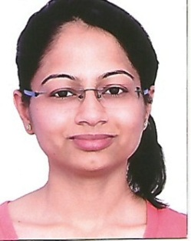
Dr PRACHI
Mobile- 9999114405
Email- prachikansalaggarwal@gmail.com
Current Location- New Delhi

CAREER OBJECTIVE
Seeking to join a reputed health organization as a Pediatrician to learn more, serve patients and children and take care of them.

PROFESSIONAL EFFICIENCY
-Thorough knowledge of child health
-Good interpersonal skills
-Love children and to interact with them

EDUCATIONAL QUALIFICATIONS
Doctor in Medicine (M.D. Pediatrics) from PGIMER and Dr RML hospital, New Delhi
Bachelor in Medicine and Bachelor in surgery(M.B.B.S) from Vardhman Mahavir Medical College and safdurjung hospital, New Delhi
HSC from GRM public school, Nangloi Delhi
SSC from K.L. Arya D.A.V Public school, Hisar (Haryana)

INTERNSHIP
VARDHMAN MAHAVIR MEDICAL COLLEGE AND SAFDURJUNG HOSPITAL, DELHI
Tenure- 16/01/2012 to 16/01/2013

PUBLICATIONS
Devki Nandan, Prachi Kansal, Neha Patharia, Parul Goyal “Induced sputum nitrite levels correlate with clinical asthma parameters in children aged 7-18 years with mild to moderate persistent asthma” JOURNAL OF LABORATORY PHYSIAN 2016 | Volume : 8 | Issue : 2 | Page : 90-95

RESPONSIBILITIES
-Providing medical care to the infants, children, and adolescents.
-Treating genetic variance and growth related matters.
-Taking care of different aspects of growth and development of organ systems of the children
-Dealing with legal responsibility of children and also their privacy
-Providing assistance to the parents, family and guardians of the children so the necessary care is taken
-Assist seniors doctors and also take their advice as and when necessary

PERSONAL DETAILS
Date of Birth- 10th April 1990
Marital Status-Married
Husband- Dr Sachin Aggarwal (M.D. Pathology)
Father – Mr. T C Kansal (Executive Engineer in DHBVN)
Mother- Mrs. Neeta Kansal (Housewife)
Brother-Mr. Rijul Kansal(Engineer)
Permanent Address-D130, Antariksh Apparments, Sector-14 Extension, Rohini, Delhi

