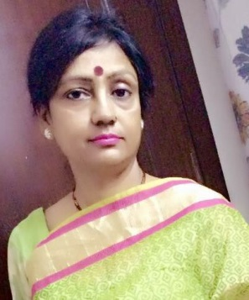

Jiva Saxena
Flat no 401 Capital Apartment
Dwarka Sec8 New Delhi-0077
8375026108 - Jivasaxena9@gmail.com

OBJECTIVE

To reach the zenith of success by working in a value based organization with my full potential and sincerity resulting in my as well organization growth.

EDUCATION

- Lucknow University , Lucnkow
- Graduate in Arts .
- Inter from .U.P Board .
- High School from U.P Board .
- Diploma in Telly.

COMPUTER SKILLS

- Microsoft Excel, Word, PowerPoint & other basic Knowledge.

RELATED EXPERIENCE

Artemis Hospital - Gurgaon

Department of Accounts & Finance . ( As a Sr. Executive of billing & cashier)
From Aug 23th 2013 to till date

Key responsibilities

- Develop, maintain and monitor all billing procedures per specific funding source.
- Follow up on all receivable balances.
- Coordinate with Accounting on accounts receivable.
- Ensure that payment received for all services is allocated properly.
- Responsible for patient,s refund & taking care of cheque records as per the policy
- Maintaining DCR on daily basis &Flash report also.
- Handeling of International payments (By USD, wire trf )
- Taking care of Credit card payments as per DCR entry.
- Responsible for all scrolls of OPD/IPD.
- Maintaing the vouchers & entry on SAP

Artemis Hospital - Dwarka

Department of Accounts & Finance . (As a Sr. Executive of billing & cashier)
From Aug 13th 2012 to 22nd Aug 2013

Key Responsibilities

- Prepairing the bills on daily basis for IPD patients.
- Responsible for the entries of bed side procidures & Surgeroies.
- Giving information to the patients about their active bills.
- Insure that every patient’s bill as per the policy (cash/TPA/ECHS/CGHS Etc)
- Maintaing the daily discharge report as per the hospital policy & responsible for the batch close for every shift.

Shubham India Distributors Pvt Ltd Lucknow
Department of Accounts –Worked as a Team Leader
9years

Key responsibilities

- Handelling bills RC & Insurance papers.
- Maintain stock register as per the requirement.
- Cash book & day book entries on daily basis.
- To ensure all team members for installment of product as per policy

Sadana Electric Stores- Lucknow
Worked as An Accountant
15years

- Key Responsibilities

- Manual billing & taking care of payments from the customers.
- Ledger maintain for credit billing customers.
- Stock entries for all items .
- Responsible for Day book, cash book & cheques on daily basis.

STRENGTHS

- Ability to understand and solve complex problems, and to make quick decisions.
- Ability to adapt to new technologies & environment quickly.
- Strong customer service and computer skills.
- Ability to align IT strategies with corporate objectives
- Ability to coordinate effectively in a team

PERSONAL DETAILS

Husband’s name : Mr. Jai Gopal Saxena
Date of Birth : 09th July 1965
Gender : Female
Nationality : Indian
Language : Hindi & English.
Hobby : Listening Music,singing & cooking.

Date :

Place : Signature

