CURRICULUM VITAE

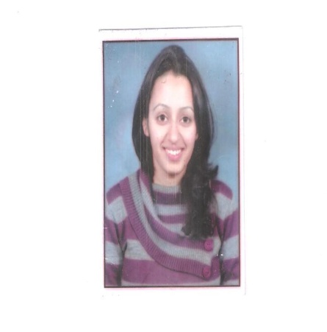
NAME: Dr SYLVIE SHARMA
AGE: 26 yrs
DOB: 21.12.1989
Permanent Address: House No-6, Block 2
Type 4, Richmond,
Shimla-17101

Present address:- E-8, 2nd floor, GK-2 ENCLAVE
NEW DELHI-110048

Contact No: +91-7042233618
Email id: sylvie30889@gmail.com/drsylviesharma@yahoo.com
Education
STD/Course | School/College Name | Board/University | Year of Passing | %
X | JNV Patiala | CBSE | 2005 | 89
XII | JNV Patiala | CBSE | 2007 | 82
BDS | Government Dental College, Patiala, Punjab | BFUHS, Faridkot, Punjab | 2013 | 63
Post Graduate Diploma in Rural Development Man(PGDRDM)  M.Phil (Hospital & Health Systems Management) | National Institute of Rural Development (NIRD), HYDERABAD  BITS,PILANI | MoRD  BITS | Dec 2014  Pursuing | 80

Internship
Organization | Duration | Position
Mata Kausalya Charitable hospital Jan 2013 | Jan 13 -Feb 13 | Dental Officer
Rural Development Programmes in Villages in AP | 15 Days Jul 14 | Research Assistant  Field and project work covering the essentials of rural economy; rural organizations; micro-finance;; livelihoods; rural product marketing; infrastructure; social sector services(- Health,sanitation,PRI’s)
Aajeevika Skills,NRLM,GOI  Aajeevika Bureau | Aug 14- Oct 14 | Project Assistant :  - To prepare Standard Operating Procedures(SOP) for Migration Support Centers.  - To draft guidelines for establishing Migration Support Centers.  - Volunteered as a dental practitioner in their health initiative: Amrit Health Clinic.  - Social mobilization and capacity building among the rural people for the health initiative as a part of organization goals
Integrated Institute for Rural Development, SHIMLA | Jan 15 - Feb 15 | Project Officer (Public Health & Women Empowerment)
WORK EXPERIENCE
Organization | Duration | Position
AXISS DENTAL PVT.LTD  Shri Ram New Horizon Ltd | OCT 15- Contd  Feb 15 - Aug 15 | - DENTAL SURGEON: The responsibilities of this position include looking into the administration and working of the clinic as well as the overall clinical practice at the centre.  - Involvement in Axiss administrative projects  - Maintain consistent performance with quality control protocols  - To undertake inductions for doctors as well as support staff  - Organize various seminars, Awareness Camps,Free Dental check up camps in schools and corporates  CENTER-INCHARGE : I am heading a Training Center in Bhuvaneshwar for ROSHNI which is a government project which trains individuals from the naxal affected districts of Odisha in the Home and Health Care sector.  KRR:-  - Monitoring the training and providing requisite assistance to the candidates, faculty, mobilizers & other capacity building staff.  - Responsible for mobilization, implementation, monitoring and reporting of the project as per project guidelines (DDU-GKY Aajeevika Skill development Project).  - Devise the plan of action for proper execution of all activities. Guide and lead a team of field workers for effective implementation of the project.  - Liaise closely with local/government bodies, training partners and industries in relation to work and represent the organization in coordination and review meetings and create a stronghold of the project in the covered area.  - Responsible for coordination of all project related activities within the team and in the field to achieve project target within given time frame and adhere to deadlines specified by the management.
Kapoor Dental Clinic, The Mall, Shimla | Jul 13 - Dec 13 | Dental Officer

Achievements
- Bronze medalist in Oral Medicine & Radiology
- National Best Speaker by Ministry of Youth and Parliamentary Affairs
- Distinction Merit holder in English in Senior Secondary by CBSE
- Succeeded in negotiating with the State Government of Punjab as the head of the Association of Dental Interns

Position of Responsibility
Chief Secretary, Association of Dental Interns, Punjab | Represented the Interns of all the State Dental Colleges while negotiating with the state government
Class Representative | 2008-12 Bridging the gap between the management, faculty and the students.

Positions undertaken as a Volunteer
Volunteer Oct 2013
- ….Oral health Check up Camp, Jawahar Navodaya Vidyalya
Patiala, Punjab
- ORGANIZER- 67TH INDIAN DENTAL CONFERENCE 21-23 FEB 2014, HYDERABAD

Hobbies & Interest
- Reading, teaching, exploring new frontiers and interacting with people from all walks of life.

Special Skills:
Competent In MS Office Applications (Word, Power Point, Excel and Access) & Tally 9.0, SPSS16, QUANTUM GIS 1.8
Brief Description About Myself: -
I am a dentist by profession with a strong inclination towards the development sector. My passion for serving the community at large prompted me to pursue a course in rural development. I have been associated with many NGO’s right throughout my career. I have volunteered with them to organize free oral health check up camps, blood donation camps and other Awareness Drives.
I believe in achieving goals set before me, and as someone who should be recognized for his work on the lines of professionalism and work etiquette. I’m equally skilled in collaborating across functional staff teams, senior directors and top management. I’m a good communicator and proficient team player and leader. I am a highly motivated individual who strives to achieve what is set before me. In addition to my single minded focus to be a thorough professional, I’m also open to new challenges which reiterate that I would thrive in high-pressure environments.
Current Salary : 4 lacs p.a
Expected Salary : 4.5-6lacs p.a
References:
- Dr Amit Sachdeva, Director, Axiss Dental Pvt Ltd.
- Mr Ravibabu Manchala, ADVISOR, AAJEEVIKA SKILLS, NRLM, GOI. Email id: ravibabunird@gmail.com
- Mr Ashish Malhotra, Sr.VicePresident, Shri Ram New Horizons LTD. Email id: ashish.malhotra@nhindia.com
I do hereby declare all the above information presented is true to the best of my knowledge.

Place:Delhi Signature,
Date:31/3/2016 Dr.Sylvie Sharma

