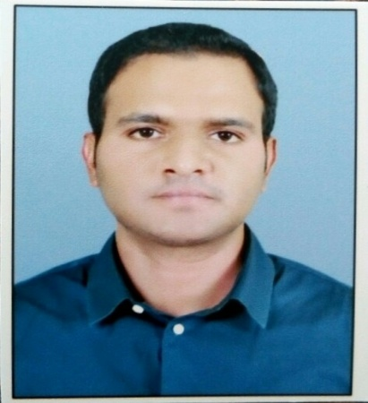
GODSON CHRISTOPHER FERNANDEZ
- T1-1101, RPS Savana, Sec-88, FBD
9818522544
godsonc3@gmail.com

Career Objective
To obtain a position where i could effectively apply my skills and knowledge i have learned and to give an opportunity to work productively and accurately in your company

Education
2012-2014 mba in hospital management
2009-2012 graduation b.a
2005-2009 diploma nursing & midwifery
2003-2005 plus two
2003 matriculation

Work Experience
Total Work Experience 7 years
- 2010 – Today RG Stone Urology & laparoscopy Hospital
Designation Supervisor [nursing & Quality & Infection Control]

East of Kailash Branch
08.03.2010 – 31.03.2011 Staff Nurse
01.04.2011 – 12.06.2011 Assistant Infection Control Nurse

GaganVihar Branch
13.06.2011 – 09.09.2012 Incharge – Nursing & Infection Control

Faridabad Branch
10.09.2012 – 31.03.2013 Incharge – Nursing & Infection Control
01.04.2013 – Today Supervisor – Nursing, Quality & Infection Control

- 01.11.2008 – 31.12.2009 Mediciti Hospitals, Hyderabad
Designation Staff Nurse [SICU]

Skills
- Proficient Computer Literacy proven through work experience – IMS, Microsoft Excel & Word [Quarterly Edition of Infection Control Newsletters]
- Exceptional Leadership skills developed through work experience
- Ability to multi-task
- Adaptability & Flexibility

Additional Achievements
2016 BLS

2015 Nursing Excellence Certification Programme held by QCI at Fortis Hospital, Gurgaon
Workshop on Implementation for NABH Nursing Excellence Certification Standards held by QCI, New Delhi

2013 ACLS & BLS [aha]
Certification Workshop on Patient Safety, held at Indraprastha Apollo Hospital, New Delhi
Certification Course of Hospital Infection Control held at Sir GangaRam Hospital, New Delhi

2012 Certification Course of Critical Care Nurses Club Meet held at Sri Balaji Action Medical Institute, New Delhi

Personal Details
Age/Sex 30/Male
Marital Status Married
Languages English, Hindi & Malayalam
Permanent address Ponnara House,
Meladoor P.O., Mala,
Near Holy Child School, Snehagiri,
Thrissur Dist., Kerala – 680741
Tel: 0480-2898165

Godson Christopher Fernandez

