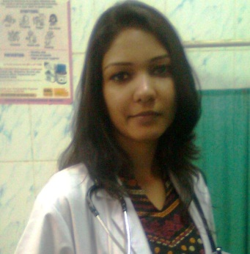
Dr. Deepali Jain
A-77, ShastriNagar, Delhi-110052
Mob: 8860010531
9818877204
DOB: 08 NOV 0988
jaindeepali0811@gmail.com

Career Objective

Seeking a position, to utilize my skills and abilities in the industry that offers professional growth.

Professional Experience

- Max Super Specialty Hospital, Shalimar Bagh 02nd Feb 2015 - till date
(TPA Incharge)
- Focus Health services (TPA) Pvt. Ltd 11 October 2013- 31st Jan 2015
(Senior Medical officer)
- Charitable Dispensary April 2012- September 2013
(Medical Officer)

Key responsibilities area

- Managing a team of 5 members thereby Imparting the process training, knowledge transfer, holding team calibration meetings so as to fulfill the client requirement with 100%quality.

- Work with management to set daily priorities to ensure prompt and effective service.

- Handling claims cashless of all empanelled TPA of various client like NIC (National Insurance company), UIIC (United India Insurance Company), LIC (Life Insurance Company), all private insurance companies ( Apollo munich, maxbupa, Bajaj allainz, religare etc ).

- Medical scrutiny of hospital documents and medical audit of all approved claims and answering queries.

- Monitoring of bills that should be made as per agreed tariff with TPA/Insurance companies., for error free billing that will help in recovery of hospital payment and minimize the risk of deduction.

- Monitoring of hospital payment from the concern TPA/Insurance companies. Replying any queries and providing any deficient documents for early recovery of hospital payment.

- Tracking of final approvals by TPA / Insurance companies during cashless. Coordinating with TPA/Insurance team during any delays.

- Monitoring of dispatch of complete set of documents comprising bills, discharge summary, reports with approval letters to TPA within stipulated time.

- Co-ordination with networking team of TPA /Insurance companies for any queries/ issues regarding payments, patients etc.

- Approval &Rejections of claims as per terms and conditions of policy.

- Giving training of all policy terms & conditions time to time to the newly joined employees.

- Coordinating with CRM team for resolving any queries come from the different corporate/insurance companies time to time.

Professional Qualifications

- B.H.M.S (Bachelors of Homoeopathic Medicine and Surgery) from Dr. B.R.Sur Homoeopathic Medical College, GGSIP University in 2011, Secured 60%

- PGDCR (post graduate diploma in clinical research)from Symbiosis Centre of Health Care, Pune in May 2013, Secured 74%.

- C.G.O (Certificate in Gynecology and Obstetrics) from AYUSH, Indore

Internship

Company Name-Dr. B.R.Sur Homoeopathic Medical College, Delhi

Project Title- Know the efficacy of homoeopathic medicines in lifestyle diseases Diabetes Mellitus and Hypertension.

Duration-1 year from 14th may 2011 to 13th may 2012

Description- Completed 1 year rotatory internship in OPD, IPD, Maternity Centre and Dispensaries.

Competencies

- Having good analytical, diagnostic and research oriented medical skills.

- Self-belief, Self Motivated and ability to grasp things quickly.

Educational Qualification

10+2in 2006, Secured 76% from Maharaja AgrasenModel School (CBSE)
10th in 2004, Secured 84%. from Maharaja Agrasen Model School (CBSE)

Declaration

I hereby declare that the above details are true to the best of my knowledge and that I’ll do my best for the good of the organization.

Dr. Deepali Jain

Date:
Place:

