MUBASHIR MAJID BANDAY
S/o ABDULMAJID BANDAY
Chandapora, Harwan, Srinagar
J&K India
Mob: +91- 7859880875, 9205112333 bandaymubashir7@gmail.com

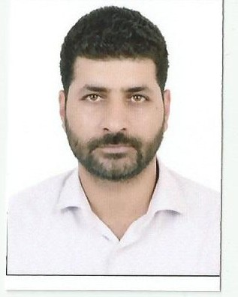

Academics
- M.B.A (Health Care & Hospital Administration), (grade-I), 2011, Global Open University, Nagaland. India.
- B.A (^{2nd}. grade), 2007,University Of Kashmir, India.
- Hr. Sec. Part II (3rd . grade), 2000, JKBOSE, Srinagar, India.
- High School (X) (2nd. grade), 1998, JKBOSE, Srinagar, India.

Paper Studied During M.B.A
- Comprehensive study of Management Process and Perspectives.
- Organization Behavior.
- Computer aided Management.
- Business Communication.
- Business Laws.
- Production and operations management.
- Business Ethics.
- Hospital, Public health Safety.
- Hospital Administration System.
- Hospital Rules and Regulations.
- Healthcare and hospital Facilities.
- Hospital counseling and Rehabilitation services.

Trainings and Achievements
- Awards  - Trainings  - Technical  - Seminar Lectures  Delivered at S.K.I.M.S | - Won 1st prize in working model of “Renewable Energy Source” at inter-district model competition held at District Institute of Education and Training (DIET) Budgam, Jammu and Kashmir in 1994.  - Won Ist prize at District Level Seminar on “Copying a Menace” at girls Hr.Sec.School Magam Kashmir in 1996  - Six Months in Hospital Administration S.K.I.M.S Srinagar From May-2011 to oct-2011  - One Year Diploma In Computer Application  - Reproductive and Child Health Services in India  - Proper Utilisation of Research Funds at large teaching Hospitals Like S.K.I.M.S  - Healthcare and Hospital Facilities in Rural Areas.  - Mother and child care nutrition in far flung Areas of Distt. Budgam.

Experience
Worked as an Health Educator at Govt. Sub-District Hospital Beerwah Budgam from (Nov-2011 to oct-2012)
Worked as a contractual Lecturer at Syed Ali Memorial Institute of Education Beerwah Budgam from Nov-2012 to Feb-2014
Working as a Quality control Manager at Mehboob Health Care Beerwah since March-2014.

Personal Information
- Date of Birth: December 15th , 1980
- Sex: Male
- Marital Status: Married
- Nationality: Indian
- Languages Known: English (fluent), Urdu (fluent), Kashmiri (fluent).
- Permanent Address: Chandapora, Harwan,Srinagar (J &K), India-191123.

Psychograph
For an institution/company that nurtures ‘intellect’, my strong analytical and logical skills will prove to be an asset. I believe I am a winner & can turn adverse situations into future opportunities. After all it’s all in the mind. Thus learn more and grow to give valuable assets to the employer and the country.

Place: Kashmir
Date: 03-09-2016 Mubashir Majid Banday

