rRESRR

*DR. VARUN PRABHA GUPTA 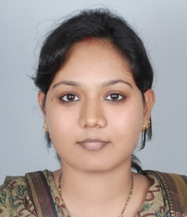*

*63, SFS, SHAKTI APARTMENT, ASHOK VIHAR, PHASE-3, DELHI-52*

*CONTACT NUMBER- 9643755130, 9968055130*

*e mail id -* [*beautyoflowers@yahoo.co.in*](mailto:beautyoflowers@yahoo.co.in) *, varunprabhagupta@gmail.com*

***CAREER OBJECTIVE****- A confident communicator and a dedicated healthcare professional, looking forward to work in an institution that provides opportunities for career growth and environment for learning.*

***PERSONAL STRENGTH-***

* *Sincerity towards job and punctuality.*
* *Interpersonal organizational skill.*
* *Strong communication skill.*
* *Can work independently or as a part of team.*
* *Hard working.*

***PROFESSINOAL QUALIFICATION-***

* *Name of the course : PGDHHM (Post graduate diploma in health and hospital management)*

*Year of passing : February 2015*

*University : IGNOU*

*Study centre : Dr.Ram Manohar Lohia Hospital, Delhi*

*Percentage of marks : 67.08*

* *Name of the course : BDS*

*Year of passing : March 2008*

*University : Dr.B R Ambedkar university, Agra*

*College : Uttar Pradesh Dental College and Research Centre, Lucknow*

*Percentage of marks : 62.86*

***PROJECT UNDERTAKEN****- A study to evaluate the awareness on biomedical waste management among nurses and paramedical staff at a Delhi government hospital.*

***EXPERIENCE-*** *4 years in various government and private hospitals as dental surgeon.*

*ALSO PURSUING PG CERTIFICATE IN QUALITY MANAGEMENT AND ACCREDITATION OF HEALTHCARE ORGANIZATION*

*Percentage of marks :67.08*