Application for the Post of Executive (TPA)

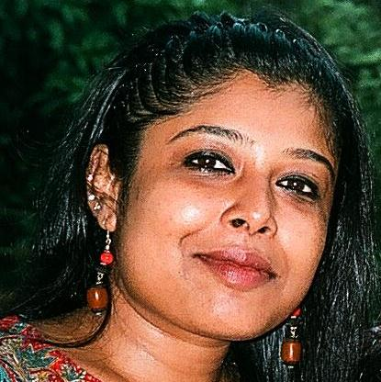

SOMA MAZUMDAR
E-825, Chittaranjan Park
New Delhi – 110 019

Mobile: 9810263218, 8587874089

E-mail: soma825@gmail.com

somamazumdar08@gmail.com

I Believe Life is a Learning Process and Every One is a Part of this Institution. For Good Working One NEED to Enjoy their Work and have Self Believe for the Achievement of the Given Task. By Doing Work and Accepting the Responsibilities, the Learning Process gets more effective.

Father’s Name | : | Shri B. P. Mazumdar
Date of Birth  Hobbies  Languages known | :  :  : | 28th July 1970  Painting, Music, Handicrafts, Embroidery  Bengali, Hindi and English
Academic Qualification | : | Matriculation from Lady Irwin School (1985)  Higher Secondary from Lady Irwin School (1987)  Graduation from Delhi University (1990)  Post-Graduation from H.P. University (1993)
Professional Qualification | : | Secretarial Course with shorthand and typing
 | : | Short-term Course in MS-Word and Excel
Job Experience | : | : At present working at Centre For Sight as an Executive - TPA since July 2014  : Worked at Bharti Eye Hospital as a TPA Co-ordinator for two months (May’13 to June’13)
 | : | Worked at Saket City Hospital as a Patient Care Executive in TPA & IPD from February 2013 to April 2013
 | : | Worked in G. M. Modi Hospital & Research Centre for Medical Sciences as a Senior Executive - TPA from April 2006 to February 2013 (07 Years)
 | : | Worked in G. M. Modi Hospitals Corporation Ltd. (New Delhi) as a Steno-Secretary in Commercial Dept. and looking after TPA processing also from December 1998 to March 2006 (07 years +)
 | : | Worked in Microtone Solutions Pvt. Ltd. as a Steno Secretary from January 1998 to November 1998 (01 year)
 | : | Worked in Stantech Project Engineering as a Steno Secretary from January 1996 to December 1997 (02 years)
 | :  : | Worked in Hegenscheidt as an Office Assistant from July 1994 to November 1995 (17 months)  Worked in Good Samaritans as an Office Assistant for few months
Nature of Duties & Job Responsibilities | : | Maintained excellent business relationships with TPAs, Other Employees/ Department and Patients
 | : | Co-ordination with TPAs to get approvals for the cashless treatment of the patient within the limited time
 | : | To actively follow for further approvals if required and inter hospital departments in case of discharge, and interacting with the TPA representatives as and when required
 | : | Co-ordination with Finance and Billing & Marketing Department for Final settlement of bills
 | : | Counseling and giving estimates to patients and satisfy the patient regarding any treatment related queries
 | : | Replying the queries and also if any queries are raised after claim submission.
 | : | Preparing the query reply with doctor’s co-ordination during the patient’s stay if any
 | :  :  :  :  : | Keeping track of the running bill of the TPA patients  Have knowledge of making discharge summary  Preparing documents as per the Medical Insurance  requirement  Completion of docket before dispatch to TPAs for  Claim  To follow-up for the recovery of payments also
 |  | (SOMA MAZUMDAR)

