RESUME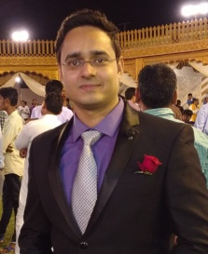
DR.PANKAJ KUMAR YADAV email: pikcool72@gmail.com
DCH (PEDIATRICS) phone: 7792092014
MBBS Resi: Alwar (Rajasthan)

PROFESSIONAL SUMMARY:
- MBBS (MUHS NASHIK) in year 2013
- DCH,PEDIATRICS (BFUHS FARIDKOT) in year 2016
- Rank 32 in Rpsc Medical officer exam 2016

EDUCATION:
- 10th std from Raj board in year 2002 ( marks 88%)
- Merit no. 22 in 10th std raj board
- 12th std from Raj board in year 2004 (marks 83%)
MBBS
- from maharashtra university of health sciences nashik(muhs) in year 2013
- From govt medical college latur
DIPLOMA IN CHILD HEALTH (DCH)
- From baba farid university of health sciences (bfuhs) in year 2016
- From govt.medical college Amritsar

SKILLS:
- Pediatric opd handling
- Pediatric emergency management
- Nicu care( ventilators/cpap)
- Procedures(exchange transfusion,surfactant therapy,mechanical ventilation,arterial and venous asses ,fluid taps,PALS)
- Others (immunization,essential newborn care,child nutrition,growth and development care)
- Dedicated and honest to work

