CURRICULAM VITAE
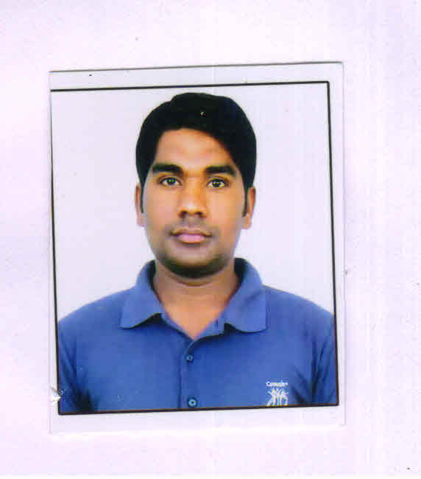
VISHAL MESI

F- 77, Khanpur colony,
New Delhi- 110062
Contact No-09560726882
Email- mesivishal@gmail.com

Carrer Objective

To seek a challenging & rewarding career in an organization this provides avenues for continuous growth utilizing my creativity & zeal to learning.

Professional Qualification

Course | Year of passing | Institute | Board/University | %of Marks
GNM 1st year | Aug 2011 | Teerthanker Parsvnath College of Nursing U.P | UP State Medical Faculty Lucknow | 73.5%
GNM 2nd year | Aug 2012 | Teerthanker ParsvnathCollege of Nursing U.P | UP State Medical Faculty Lucknow | 68%
GNM 3rd year | Aug 2013 | Teerthanker ParsvnathCollege of Nursing U.P | UP State Medical Faculty Lucknow | 65.5%
GNM Internship 6 months | March 2014 | Teerthanker Parsvnath College of Nursing U.P | UP State Medical Faculty Lucknow | 68%

Registration | Examining Body | Reg. No
Registered Nurse and Midwife | UP. STATE Medical Faculty Lucknow | 26119

Educational Qualification

COURSE/DEGREE | NAME OF INSTITUTE | BOARD/UNIVERSITY | YEAR OF PASSING
Higher Secondary | S.B.S.H.S.S ANGOOR PUR GAZIPUR(UP) | board of High school & Intermediate Education (U.P.) | 2007
10+2 | Govt. Raza Inter college RAMPUR (UP) | board of High school & Intermediate Education (U.P.) | 2009

Employee EXPERIENCE: - 1 year & 4 months

Name of Hospital | Post | From | To | Department | Bed Capacity
P.S.R.I Hospital | STAFF NURSE | 12-MAY-2014 | 7-Sep.2015 | G.w. gastroenterology | 150

personal Achivment

Best new comer 2014-15 in psri Hospital new delhi

Best perfor mer in nursing 1 aprail to 30 june 2015 in psri Hospital new delhi

PERsonal Profile

name Vishal Mesi
father’s Name Mr. Geedaveen Rait
d.O.B 08-08-1991
nationalty Indian
sex Male
marital status single
language known English, Hindi
permanent Address Vill- Imarta
Post- Khempur
Teh & Distt-Rampur (UP)
Pin Code 244901

Passport details

passport number k7785793
date of isue 07-03-2013
date of expiry 06-03-2023
place of issue Bareilly

Declaration;-

I consider myself as an extrovert. My parents are my best teacher. I invest a good amount of time in educating myself through books. I am hard working and professional who believes strongly in medical ethics and practice nursing as a divine job.
I here declare that the above information is correct and true to the best of my knowledge.

PLACE: Vishal Mesi

DATE

