DR. HIMANI TANDON
08874089296 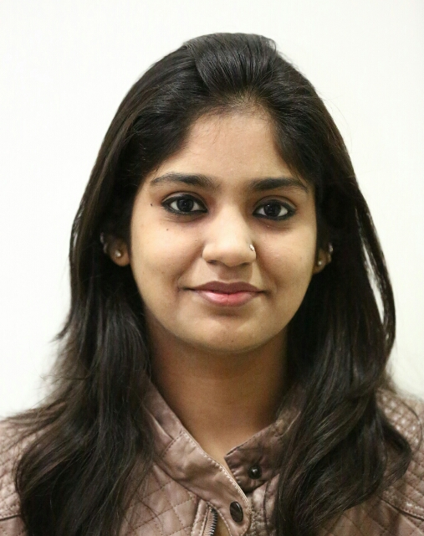
cutezwinky@gmail.com

CAREER OBJECTIVE
To join a reputed and growth oriented health organization/ hospital to provide Healthcare services to the patients using my knowledge in medical science and acute sense of medical analysis

EDUCATIONAL QUALIFICATIONS
-MBBS(batch 2010-11) from Era's lucknow medical college, lucknow affiliated to Dr. R. M. L avadh University, faizabad, Uttar Pradesh
1st year- 59.5% (first attempt)
2nd year - 67.8% (first attempt)
3rd year part I- 65.25% (first attempt)
3rd year part II- 61.55% (first attempt)
-SSC from vishal Bharti public school, new Delhi (CBSE Board) in the year 2010 with 78.8%.
-HSC from vishal Bharti public school, new Delhi (CBSE Board) in the year 2008 with 81.8%.
WORK HISTORY
Internship:
One year compulsory rotatory internship from 31-3-2015 till 30-3-2016 done from Era's lucknow medical college, lucknow
- Ordered and executed diagnostic tests and analyzed diagnostic images to further investigate patient conditions.
- Prescribed preoperative and postoperative treatments and procedure, such as sedatives, diets and antibiotics.
- Monitored patient’s condition and progress and re-evaluated treatment as necessary.
- Developed open rapport with patients, encouraging them to share questions and concerns.
- Continuously maintained proper safety and took precautionary measures to avoid the spread of disease and infection.
-In case of emergency gave the basic treatment to the patients.

FIELDS OF INTEREST FOR POST-GRADUATION
1. MD DERMATOLOGY
2. MD RADIOLOGY
3. MD MEDICINE

PERSONAL SKILLS
- Polite
- confident
- Helping nature
- disciplined
- good organization skills
- calm under pressure

EXTRACURRICULAR ACTIVITIES
- Participated in camp organized in lucknow by our college to give free medicines and treatment to the poor people.
-Voluntary work.
-Participated in cultural activities in college.

PERSONAL DETAILS
NAME : Dr. Himani Tandon
FATHER'S NAME : Mr. Vijay kumar tandon
ADDRESS : A-3/118,Paschim Vihar, New Delhi - 63
DATE OF BIRTH :9th January 1993
SEX : Female
NATIONALITY : Indian
MARITAL STATUS : Unmarried
LANGUAGES KNOWN : English and hindi

DECLARATION
I hereby declare that the above facts are true and best to my knowledge.
(DR. HIMANI TANDON)

