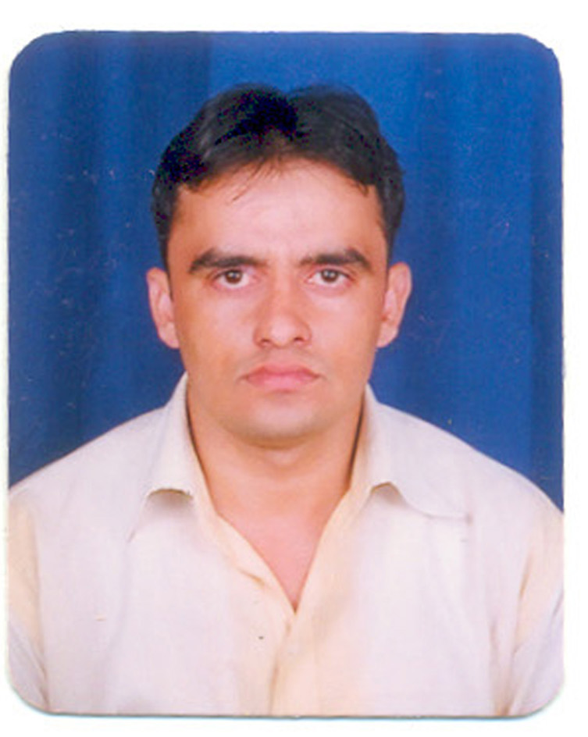
VINOD KUMAR SHARMA
H No-140, Kavita Cololy, Nangloi, New Delhi
E_Mail –vinod.sandliya@gmail.com
Vinodsandliya905@yahoo.com
-91-9910237120, 09729711511
CARRER OBJECTIVE
To be a sagacious professional working to wards organization aims and individual goals
PREVIOUS EMPLOYEE
WORK EXPERIENCE:
PARK HOSPITAL, HEART & LUNG INSTITUTE
310-BEDED (ISO 9001: 2000 Certified)
Location - New Delhi (Chowkhandi)
Designation - Billing Executive
Period - April 2006to May 2010

CURRENT EMPLOYEER :
SRI BALA JI ACTION MEDICAL INSTITUTE
Location - New Delhi (Paschim Vihar)
Designation - Senior Billing executive
Period - June 2010 to till date

Functional Responsibility:

- OPD Billing
- IPD Billing of all general patients, Patients from the TPA companies and CGHS patients.
2. Developing MIS like:
Advance & Requirement amount list of surgery case
Discharged without bill
Pending payments of cash patients, already discharged by the management.

3. Verification of TPA census like checking of authorization & his conditions with limitation, the amount that should be collected from patient.
4. Billing
CGHS / ECHS billing for Panels like FCI, NDPL, Delhi Police and Delhi University, MMTC, DTC, SBI etc.
TPA billing like Alankit, Paramount, E-meditek, Raksha, Vipul, FHPL etc on Hospital rate/ Agreed tariff.
Activities Handling
Regular Follow-up with defaulters to recover critical Errors
Knowledge of OPD & IP Billing

EDUCATIONAL QUALIFICATION
10th Passed
12th Passed
B.A Passed

PROFESSIONAL QULIFICATION
One Year Computer diploma
Knowledge in MS office, Shivam Software & Busy all version

PERSONAL PROFILE
Father’s Name : Sh. Banarasi Dass
Sex : Male
Date of Birth : 01.01.1982
Marital Status : Married
Nationality : Indian
Language Known : Hindi, English
Hobbies : Writing, Listening Soft Music
E-Mail : vinodsandliya@yahoo.com
Hello : 09910237120
Salary Expectation : Negotiable
Date:
Place: (Vinod Kumar Sharma)

