Curriculum Vitae

Name |  | 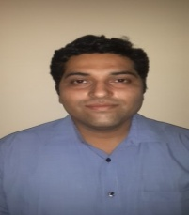  Manidip Chakraborty  E-121 First Floor  Vishwas Park Uttam Nagar  Near Sec 5 Dwarka  New Delhi 110059
Contact |  | +91-9716604064  urwithmanidip@gmail.com
Work and Education
May 2013 to …. | - Senior Resident General Surgery  Deen Dayal Upadhaya Hospital,  Hari Nagar  New Delhi
November 2012 to May 2013 | - Senior Resident General Surgery  Jeevan Mala Hospital,  Karol Bagh  New Delhi
July 2012 to November 2012 | - Senior Resident General Surgery  Fortis Jessa Ram Hospital,  Karol Bagh  New Delhi
June 2009 to  June 2012 | M.S General Surgery  Lala Lajpat Rai Memorial Medical College  Meerut  Uttar Pradesh
March 1999 to September 2004 | M.B.B.S  Guwahati Medical College  Guwahati  Assam

