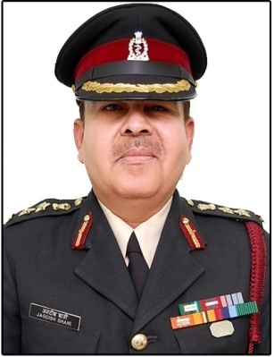
CURRICULA VITAE IN RESPECT OF COLONEL (DR) JAGDISH RAI SHAHI
Email jagdish_shahi@yahoo.com , <afp15jagdishrs@iimahd.ernet.in>
https://in.linkedin.com/in/colonel-dr-jagdish-shahi-55468010a Mobile no. 09217791260
Date of Birth : 01 January 1958
Rank in the Army Medical Corps : Colonel
Service in the Army Medical Corps : 30 years
Honours and Awards:-
1-Commendation of the GOC-in-C Northern Command
2-Commendation of the GOC-in-C Eastern Command
Core competence:
1-Hospital Management /Hospital Administration/Hospital Operations
2-Hospital Logistics ,Hospital Human Resource Management
3-Organisational Leadership
4-Crisis Management
Academic Qualifications :
1-MBBS – Govt Medical College Patiala – (1975-1980)
2-PG Course in Health Management – National Institute of Health – New Delhi -1996
3- PG Course in Hospital Management – National Institute of Health – New Delhi -1998
4-PG Diploma in Maternal and Child Health – Christian Medical College– Ludhiana -2000
5- PG Diploma in Geriatric Medicine– Christian Medical College– Ludhiana -2002
6- PG Training in General Medicine and Neurology– Govt Medical College Patiala – (2004-2007)
7-MBA - IIM Ahmedabad -2015-2016
Academic Publications:- In the Annals of Indian Academy of Neurology and Co-authored several chapters of Neurology in the Text Book of Geriatrics .
Career Summary :
Vast experience of over 30 years in the Army Medical Corps comprising of :-
1- Senior Executive Command Appointments as Commanding Officer in the rank of Colonel
of following Tertiary care Military Hospitals equipped with ultra modern diagnostic equipments , intensive care units , operation theatres and specialized wards through out India including in counter insurgency and diffificult geographical areas of the country :-
(a)-500 Bedded - Military Hospital Amritsar
(b)-300 Bedded - Military Hospital Bhuj (Kutch)
(c)- 300 Bedded - Military Hospital Leimakhong (Manipur/Imphal)
(d)-300 Bedded - General Hospital Patiala (Punjab)
(e)-200 Bedded - Field Hospital deployed in field areas of Arunachal pardesh
(f) -200 Bedded - Border Roads Hospital at Tuensang (Nagaland)
(g)-200 Bedded - Border Roads Hospital at Mon (Nagaland)
2-Commanded a 2000 Bedded Ambulance Train Hospital equipped with ultra modern diagnostic equipments , intensive care units , operation theatres and specialized wards deployed in the war zone.
3-Registrar of a 2000 Bedded Tertiary care Super specialist Govt Medical college Hospital.
4-Vast experience in the Management of all aspects of Hospital comprising of Hospital operations , intensive care services , out patient services , Hospital logistics , Hospital human resource management ,crisis management ,Disaster Management and welfare of patients.
5- Organisational Head as Senior Executive Medical Officer in the rank of Colonel of Ex Servicemen Contributory Health Scheme for over 12 years, since its inception in 2004.
6- As Senior Executive Medical Officer of Ex Servicemen Contributory Health Scheme
Exercised Technical control over more than 50 ECHS Empanelled Tertiary care corporate Hospitals through out the country for ensuring quality ECHS services to ECHS patients.
7-As Senior Executive Medical Officer of Ex Servicemen Contributory Health Scheme
Established, Operationalised , Directed, Controlled and Supervised the technical functioning of a large no. of Ex Servicemen Contributory Health Scheme polyclinics through out the country.

