adhil saleem  customer care executive |  | 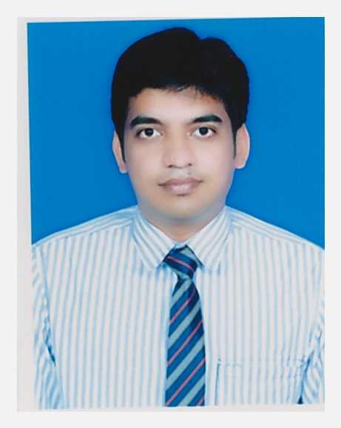  Email: mohamedaadhi@gmail.com  contact- +91 9894808429
DOMAIN EXPERTISE:
FOOD & BEVERAGE MANAGEMENT OF HOSPITALITY INDUSTRY- Daily operations of restaurants, commercial kitchens and other establishments that provide food and beverage service to customers.
FRONT OFFICE DESK – Interacting with customers, meet and greet filing and mail distribution. Using computers with MS Office.

WORK EXPERIENCE IN TOTAL: Two years of experience in Ass Unit In charge Five years’ experience in Food & Beverage Industry.

WORK EXPERIENCE

CUSTOMER CARE EXECUTIVE(front office) April 2013 – April 2015
Aster Medical Centre, Doha, Qatar
JOB DESCRIBTION:
- Welcoming and greeting all patients and visitors, in person or over the phones.
- Answering the phone while maintaining a polite tone, consistent phone manner using proper telephone etiquette.
- Responsible for keeping the reception area clean and organized.
- Registering new patients and updating existing patient demographics by collecting patients detailed information.
- Facilitates patient flow by notifying the provider of patients' arrival, being aware of delays, and communicating with patients and clinical staff.
- Communicating with doctor if there is any necessary.
- Handling cash and maintaining register for excess and short.

F&B ASSISTANT February 2010 – October 2011
Hilton Croydon, London.
FRONT OFFICE / WAITER February 2007 – December 2008
Ashby Hotels, Trichy, Tamil Nadu, India
JOB DESCRIPTION:
- Helping with the daily operations of restaurants, commercial kitchens and other establishments that provide food and beverage service to customers.
- Report to the food and beverage manager and responsible for front-of-the-house dining room operations.
- My focus on maximizing the profitability of food and beverage operations and carry out menu strategies and promotions to meet this goal.
SKILLS:
- Food and Beverage operations.
- Menu strategies, daily operations of restaurants.
- Room service and Banquet
- Micros system experience
- Cash up in restaurant
- MS Office knowledge
- Software Knowledge in Java, Visual Basic and Web Designing.
- Client / Customer Interactions.
- Greeting and Receiving Guests.
- Receiving complaints, Filing and Mail Distribution.

EDUCATION

ADVANCE DIPLOMA IN TRAVEL TOUR AND HOSPITALITY- 2011
London Training College – UK

DIPLOMA IN CATERING & HOTEL MANAGEMENT (D.C.H.M )- 2006
S.R.M Deemed University, Tiruchirappalli, Tamil Nadu, India

ADVANCED DIPLOMA IN CULINARY ARTS - 2011
CITY & GUILDS, U.K

TRAINING
Organization: JAYPEE PALACE (5 Star Deluxe)- Agra, India
Duration: 1 Month
Job title: Industrial Trainee
Job Profile: Food & Beverage Service operations.

Organization: Buena Vista Beach Resort - Chennai, India.
Duration: 6 Months
Job title: Industrial Trainee

ACHIEVEMENTS

- Got reward for best employee of the month.
- Completed Health and safety course conducted by Hilton.

PERSONAL INFO

Date of Birth : 21-Oct-1987
Nationality : Indian
Marital Status : Married
Linguistic Ability : English, Arabic, French, Urdu, Tamil, Hindi,
Passport No :
Driving License : Indian License

DECLARATION

I hereby declare that the above written particulars are true to the best of my knowledge and belief.

