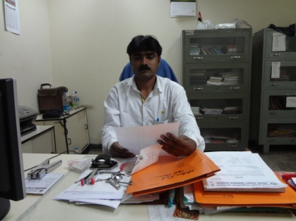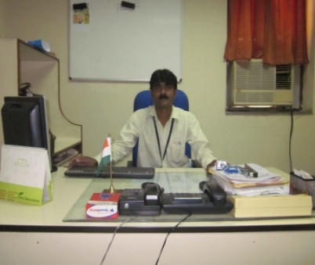

To work in a challenging environment demanding all my skills and efforts to explore and adapt myself in different fields, and realize my potential and contribute to the development of organization with impressive.

**Objectives**

**Professional Qualification**

**Experiences**

* Specialization in Hospital Management/Hospital Administration
* **B.Sc. (Hospital Management/Hospital Administration).**
* **PGDHM**-**Post Graduate Diploma in Hospital Management.**
* **MBA based training from Christian Institution U.P.**
  + - **Special two months exposure/observation training as Hospital Administrator/Manager from LAICO Aravind Institute, Madurai, Tamil Nadu**
    - **Attended Special training workshop at All India Institute of Medical Sciences Delhi regarding Inventory/Purchasing Management.**
* **Excellent PowerPoint presentations**
* Computer knowledge (MS Office, MS PowerPoint, Windows, MS Excel, Internet and Tally
* Professional Windows/Ms Office/Ms Excel/Internet/PowerPoint presentations & Tally.
* English & Hindi Typing on computer as well as on type writer also.
* Good knowledge of English writing and speaking/communication skills
* Self correspondence & budget/proposals/reports/minutes of meetings
* Good communication skills
* Health education course.
* All Management of Office and Admin as Office Manager/Office Coordinator
* Day to Day functioning of the Hospital
* To check all the records, staff, departments etc.
* To handle all the HR Department as HR Manager
* Teaching to Paramedical Girls & Boys
* Worked on Mahila (women empowerment)
* Arrangements of Institutional events
* Laisoning with NGOs/Govt. & Funding Agencies.
* Inventory & Purchasing Management & Stores
* All the administrative work
* Attract, retain and motivate staff. Manage the recruitment processes and ensure candidates fit the role and hospital/Institution culture.
* Identify training/skills/competency needs within the organization.
* Implement and monitor compliance to Institutions/hospitals.
* Responsible for providing an effective and efficient human resource generalist function that is aligned with departmental and Institution strategic and goals.
* Arrangements of CMEs
* Arrangements of faculty guests etc.
* Worked on Rehabilitation (CBR)
* Monitoring all the hospital system
* Worked for women empowerment in society
* Worked in Methodist Christian Hospital & School -Mursan as Office In charge/Secretary under supervision of Missionary foreign Director from NORWAY in HR & Administration.
* Worked in NIRPHAD Charitable Health & Child Development NGO (HCDI) Rural Eye & Rehabilitation Hospital Chhatikara-Mathura funded by Germany under supervision of Director/Administrator as project incharge & Administration.
* Worked in SIPFSA Health Project (Mother & Child) -Agra as In charge/Accounts Officer under supervision of Project Director/Project Coordinator. HR & Administration
* Worked in Hotline Express Co. Delhi as Office Assistant.
* Worked in Ratan Lal Phool Katori Girl’s Inter College Vidya Bharati as Office Assistant.
* Worked in Swarn Jayanti Samudaik Multi Specialty Hospital-Mathura which is built by Indian Oil Corporation Limited **(Refinery)** by the order of Hon’ble Supreme Court of India and managed by an NGO **(NIRPHAD)** as Office In charge since 2008 to 2013. In HR & Administration.
* **Presently: -** **Working at India’s very famous hospital named Sitapur Eye Hospital Trust as Senior Manager Hospital-Operations & HR since 2-3 years to till date. In HR & Administartion.**

EDUCATIONAL QUALIFICATIONS

* Bachelor Degree, **B.Sc.** Science & Hospital Management.
* PGDHM (Post graduate Diploma in Hospital Management)
* MBA based training from Christian Institute U.P.
* Special training as Hospital Administrator from Aravind Institute, Madurai-Tamil Nadu
* Intermediate (Science)
* High School (Science)
* Computer Diploma
* English & Hindi Typing
* Health Education Certificate
* Inventory Supply Management certificate
* Conference attended legal issues, labour law

JOB DESCRITION-DONE/AND DOING PRESENTLY

* I am handling all type of official work as an Administrator/office in charge in the Administration/Management of the Institution.
* Day to day operations of the hospital.
* Purchasing/Stocks inventory of all the hospital/physical verification.
* Purchasing procedures.
* Control/dealings over the staff.
* Arrangements of meetings/conferences/ etc.
* Keep all the employees related data and their documents and holding them in personal custody.
* Handles all the documentation work.
* Handles staff attendance/leaves status/salaries/absents.
* Deals outsiders visitors and telephonic conversations.
* Deals public & communication with them
* Deals foreign delegates and students from abroad for Interns
* Prepares minutes of meetings and reports.
* All type of correspondences in English and Hindi also.
* To prepare PowerPoint Presentations and shows on projector in the meeting/conferences.
* Appointments/suspensions/dismissal/notices/circulars etc.
* Dispatching work.
* Handles the Organization Court cases.
* And other work according to senior’s order.
* Handling all legal matters of the Institution as Court cases any legal matters having the nice knowledge of legal matters.
* Organize & make arrangements for any National Programmes as Independence Day, Republic Day and cultural programmes also.
* Organize & make arrangements for Family Planning Camps also
* Field health programmes also
* Any other work assigned by the Administration

**Special appreciations:**

**Dealing National & International Interns from Canada, Spain & America since last 5 years as in charge.**

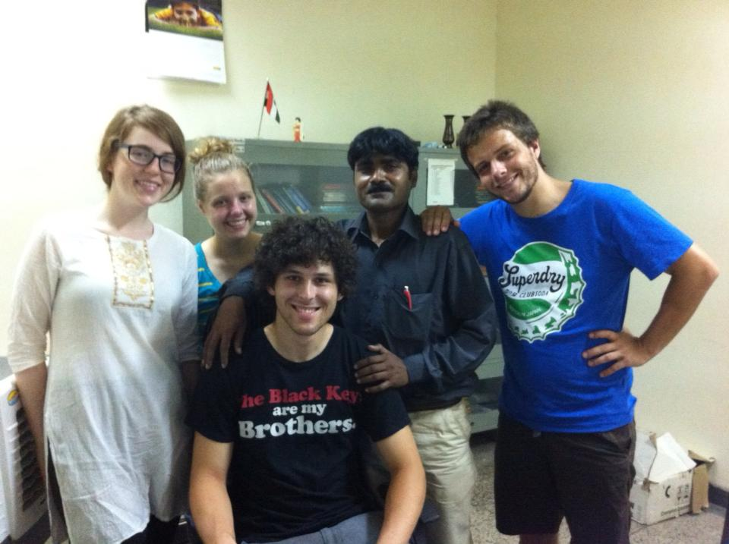 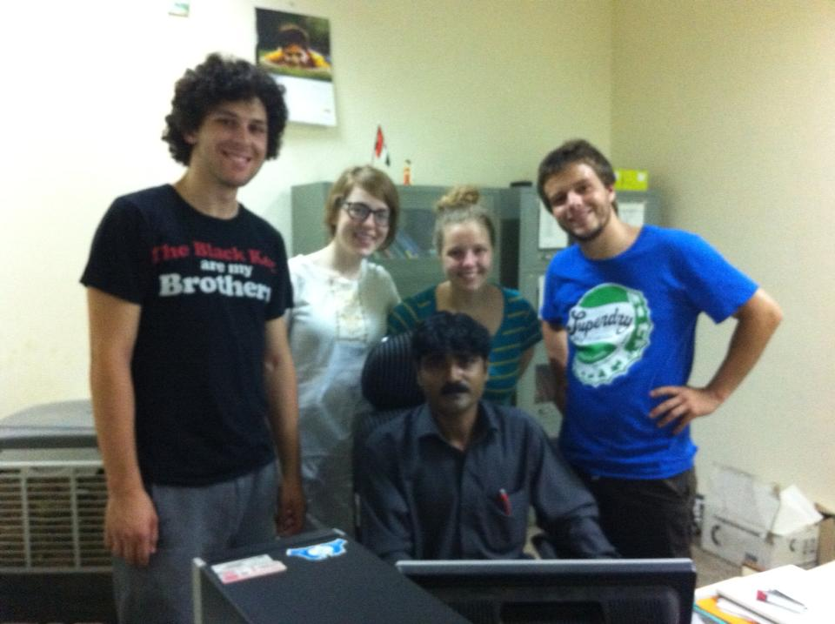

**Doctors from Canada & Spain**

* Laval University students from Canada have given special appreciation notes to me for my hard work/hospitality and sincerity.

* The Director/Coordinator/Administrator also appreciated my work time to time due to my work performances, hard working, and honesty.

COMPETENCIES

* Quick learner, adapt well to changes and pressures in workplace.
* Work effectively with diverse groups of people.
* Coordinates well with team member.
* Able to relocate anywhere.
* Committed to deadlines and schedules.

Salaries/Package: Current salary Rs. 50,000/- pm + semi furnished residence.

Expectations: Nil as per the management committee decision.

Personal Details:

Father’s Name: Late. Mr. Prem Dass

DOB: 01/07/1971

Permanent Address: Central Methodist Church Compound, Sadar Road-Mathura (U.P.)-India

Marital status: Married

Religion: Christian

E-Mail ID & Contact No. [cmassey@rediffmail.com](mailto:cmassey@rediffmail.com) 9473807793, 8755356852

References: Dr V K Pal (Medical Superintendent & Professor RIO)

Phone No. 09415035067

Note:-My wife is a good lab technician having 12-15 years work experiences from various reputed hospitals and she has also the extra experiences of registration clerk and general nursing care. Presently she is working in the same hospital as Lab Incharge.

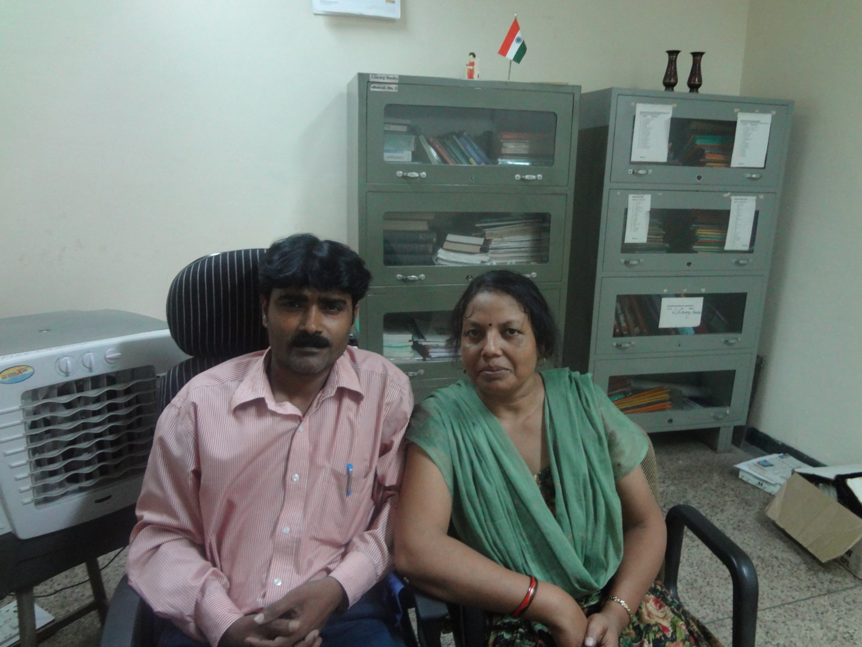

DECLARATION

I hereby declare that the above-mentioned information is true to the best of my knowledge.

**Charan Massey**