CURRICULUM VITAE 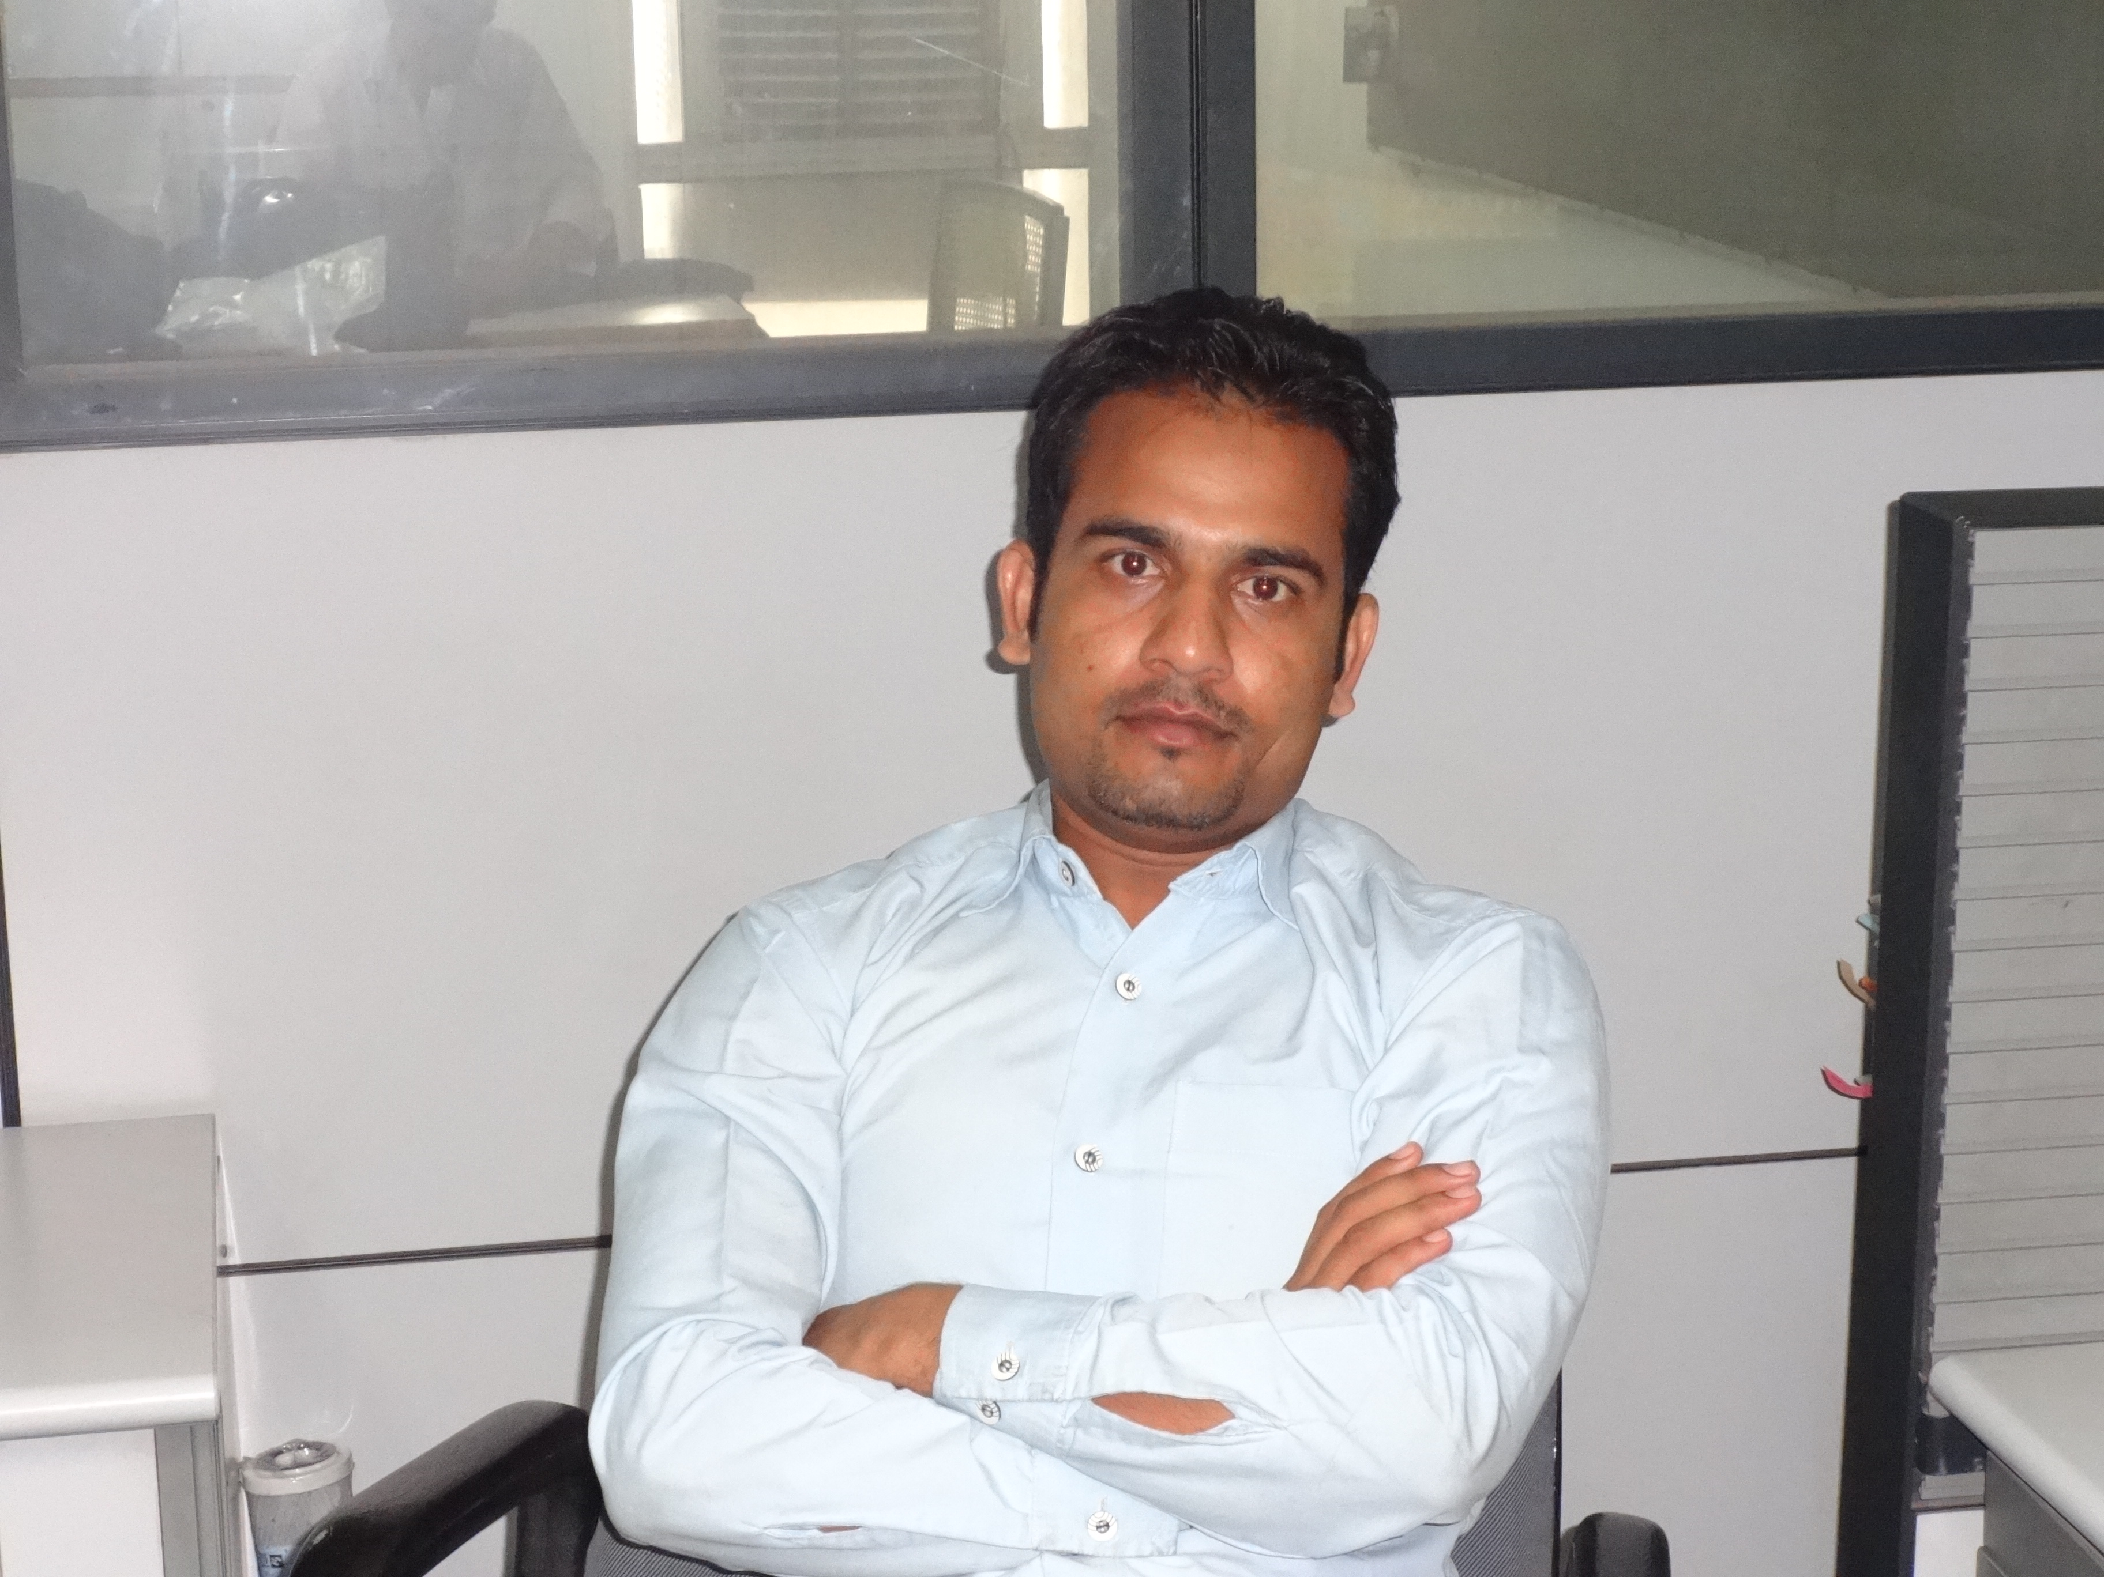

RIHAN KHAN
H-35, jamia nagar, Okhla, New Delhi
E-mail:Rfarhat18@yahoo.com
Mob.9911499302, 9873912861
CAREER OBJECTIVE
To grow as an effective Professional and drive the company in a manner which will help the company to move towards the higher targets as well as to help myself to strengthen my job competency and grow within the Company.

ACADEMIC AND PROFESSIONALS QUALIFICATIONS

- Passed Diploma of Engineering (Civil) 1st division from Jamia Millia Islamia central university New Delhi.

- Passed Higher Secondary (10+2) with 1st division in 2005 (U.P Board )

- Passed Matriculation with 2nd division in 2003 (U.P Board )

- Completed an AUTOCAD course of 6 months from DEHLI.

- Passed Diploma of Fire & Industrial safety management in 2013.

- Certificate of Temporary Works Safety on EIL

- Certificate of Strengthening Energy Management System based on ISO/FDIS 50004

- Certificate of Awareness Programme on Fire Safety from NSC (Mumbai)

- Basic knowledge of computer and Microsoft Word , Ms Excel, Power point, SAP, Internet.

Experience:
I am having an experience of 6th Year in all types of civil construction works viz., ICD & industries. Railway track, residential buildings, and industrial buildings/structures & ware house & turnkey projects.

Current Experience: Tunkey project & maintenance Food industry project. .
CURRENT COMPANY DETAILS;

Company : MOTHER DAIRY FRUIT & VEGETABLE (P) LTD.

Designation : Estate Executive Engineer.
Timing : 17 Oct.2012 -till date

Company :JPR Balaji paver pvt Ltd.

Designation :Project junior engineer (Civil), Job timing march 2010 – 15 oct.2012

Responsibilities:

* Making a tender document & administrative work at SAP soft ware.

- BBS all types of the buildings, footings, rafts, slabs, beams.etc.

- Supervision of all types bricks and plasters in the buildings.

- Super vision of the all types of RCC works and order to quantity of the RMC

- Reading all types of the drawings.
- I have a good knowledge of AUTO LEVEL & TEODOLITE

- I can do estimating &castings and quantity surveyor.

- Reconciliation of materials.

- Work done reconciliation & other documents for MIS.
- HDPE Pipe Line laying with fitting assemble

- Sub contractor bill preparation and checking M.B of Sub-contractors
.
- Preparation of work orders for Sub-Contractors.

- Regular Contractual Correspondence with Clients.

- Quantification of Acceleration measures taken and submitted to Client for extra
Billing.

- Maintaining a proper record of Salient features of the Contract, Important Submittals, Observation on important Clauses, Entitlement E.O.T/Cost Clauses,

- Maintaining Joint measurement with client and preparations of monthly bills.

- Other correspondence with client.

- Storm water line and sewerage water line.

- Supervision of the RMC plant constructed by the drawing.

- Execute all maintenance work.

- Execute all new projects with estimate.

- Site supervision & managing the manpower.

- Maintain progress report & daily report.

- Project management
- Vendor development

- Supplier relationship management

AMITY CONTRACTOR PVT. LIMITED.

Position: Site Engineer – FEB. 2009 to MARCH2010

- Construction Plant & Maintenance of service Building & Roads.

- Constructed the trusses & ware houses, residential buildings.

- Supervision of new Constructed commercial project and housing at Delhi.

PERSONAL INFORMATION

Date of Birth - Dec 18th 1987
Nationality - Indian
Marital Status – Unmarried
Languages - English, Hindi
Present Address – Okhla
Passport No – K0437124
Pancard No - BGGPK2952L

RIHAN KHAN

